

Final Year Project Report

LM051 Bachelor of Science in Computer Systems

**The Design and Implementation of Modern 3D Rendering Engines**

Author: Rónán Quill

Supervisor: Dr. Patrick Healy

Date: 27/04/2021

**Acknowledgements**

I would like to thank Dr. Patrick Healy for his supervision and guidance throughout this project and for his CS4185 Computer Graphics 1 module, which taught me the foundational knowledge that allowed me to undertake this project. I would also like to thank my friends and family for their support throughout the years in my academic endeavours.

Table of Contents

Table of Figures i

Table of Equations ii

Table of Code Samples iii

1 Introduction 1

2 Related Work 2

3 Rendering Engine Architecture 4

3.1 Introduction 4

3.2 Scene Management 4

3.2.1 Game Objects 4

3.2.2 Components 5

3.2.3 Scene 7

4 Vulkan 8

4.1 Introduction 8

4.2 Descriptor Management 8

4.3 Memory management 9

5 Physically-Based Rendering 11

5.1 Introduction 11

5.2 The Physics of Light 12

5.3 Microfacet Theory 13

5.4 The BRDF 14

5.5 Direct Lighting Implementation 15

5.5.1 Shaders 15

5.5.2 The Diffuse BRDF 16

5.5.3 The Specular BRDF 16

5.5.4 The Normal Distribution Function 17

5.5.5 Fresnel Reflection 18

5.5.6 Geometric Attenuation (Geometry Function) 19

5.5.7 Energy Conservation 20

5.5.8 Results 20

5.6 Indirect / Environment Lighting 21

5.6.1 Environment Map / Image-Based Lighting 21

5.6.2 Calculating the Environment Light Contribution 23

5.7 Results 25

6 Rendering Systems 26

6.1 Deferred Shading 26

6.1.1 The G-Buffer 27

6.1.2 Geometry Pass Implementation 28

6.1.3 Lighting Pass Implementation 29

6.2 Compute Shaders 29

6.3 Tiled Shading 30

6.4 Clustered Shading 31

6.4.1 Generating the Clusters 32

6.4.2 Determining Active Clusters 33

6.4.3 Culling the Lights 33

6.4.4 Shading the Scene 34

7 Transparency 36

7.1 Introduction 36

7.2 Sorted Transparency 36

7.3 Order-Independent Transparency 37

7.4 Moment-Based Order-Independent Transparency 38

7.4.1 Implementation 38

8 Ambient Occlusion 42

8.1 Introduction 42

8.2 SSAO 42

8.3 HBAO 43

9 Acceleration Structures / Culling 45

9.1 Introduction 45

9.2 AABB 45

9.3 View Frustum 46

9.4 Collision Detection 48

9.5 Octrees 49

10 Conclusion 52

11 References 54

# Table of Figures

Figure 2.1 Battlezone Atari Inc. (Released 1980) 2

Figure 2.2 Cyberpunk 2077 CD Projekt RED (Released 2020) 2

Figure 3.1 Rendering Engine Render Stages 4

Figure 3.2 Example of parallel directional light rays 6

Figure 3.3 Point light source in the unity game engine 6

Figure 4.1 Nvidia recommended memory layout strategies (Hebert, 2016) 10

Figure 5.1 Microfacet example (Learn OpenGL, 2016) 13

Figure 5.2 Microfacet light scattering example (Learn OpenGL, 2016) 13

Figure 5.3 Effects of NDF as roughness increases (Learn OpenGL, 2016). 17

Figure 5.4 Results of applying direct lighting PBR BRDFs to a range of materials 20

Figure 5.5 Irradiance map 22

Figure 5.6 pre-filtered environment map (Learn OpenGL, 2016) 23

Figure 5.7 BRDF integration map (Learn OpenGL, 2016) 23

Figure 5.8 Results of PBR shading. Left: Excluding environment light. Right: Including environment light. 25

Figure 6.1 Basic G-Buffer 27

Figure 6.2 Optimised G-Buffer 28

Figure 6.3 An example of a possible G-buffer layout used in Rainbow Six Siege. In addition to depth and stencil buffers, four render targets (RTs) are used as well (Akenine-Möller, et al., 2018). 28

Figure 6.4 G-Buffer contents after geometry pass, from left to right: albedo layer, surface normal layer, metallic-roughness layer and dept buffer of Sponza scene (in-engine). 29

Figure 6.5 Example of render target tiles (Unity Technologies, 2019) 30

Figure 6.6 Example of tile frustums in tiled shading (Jeremiah, 2015) 31

Figure 6.7 Clustered shading cluster example (Unity Technologies, 2019). 31

Figure 6.8 Scene rendered using clustered shading with 6.7 million triangles and 10,000 dynamically moving point lights (This scene is intentionally quite dark as the light sources are small and environment light has been disabled). 35

Figure 7.1 Example of alpha blending (Dunn & Bavoil, 2014) 36

Figure 7.2 WBOIT (left) vs MBOIT (right). Note the strange darkening and depth discontinuities in the smoke on the left image caused by WBOITs inability to render near opaque materials. 38

Figure 7.3 Left: transparent material, Right: absorbance values for each pixel 41

Figure 7.4 Left: Opaque material, Right: Final composited image 41

Figure 8.1 Examples of effects of low sample counts and random noise on SSAO quality 43

Figure 8.2 HBAO The red line represents an occlude. (Lenaerts, 2013) 43

Figure 8.3 HBAO off 44

Figure 8.4 HBAO on 44

Figure 9.1 AABB (MDN contributors, 2021) 45

Figure 9.2 View Frustum (Unity Technologies, n/a) 47

Figure 9.3 Example of an Octree (Truong, et al., 2019) 50

Figure 9.4 Spatial subdivision using an octree (Truong, et al., 2019) 50

Figure 9.5 Culling Disabled. G-Buffer generation pass: 12.09ms 51

Figure 9.6 Culling Enabled. G-Buffer generation pass: 8.76ms 51

# Table of Equations

Equation 5.1 The Rendering Equation 14

Equation 5.2 Cook-Torrance Approximation (Karis, 2013) 14

Equation 5.3 Lambertian Diffuse 16

Equation 5.4 Disney Diffuse (Burley, 2012) 16

Equation 5.5 GGX/Trowbridge-Reitz (Learn OpenGL, 2016) 17

Equation 5.6 Fresnel reflection Schlick approximation (Learn OpenGL, 2016) 18

Equation 5.7 Schlick-GGX (Karis, 2013) 19

Equation 5.8 Geometric Attenuation: Smith Method 19

Equation 5.9 Cook-Torrance Reflectance Equation (Learn OpenGL, 2016) 21

Equation 5.10 Cook-Torrance Reflectance Equation Split into Diffuse Component and Specular 21

Equation 5.11 Split sum approximation 22

Equation 6.1 Original depth slice formula (Olsson, et al., 2012) 32

Equation 6.2 Configurable depth slice formula (Ortiz, 2018) 32

Equation 6.3 Depth slice recovery formula 32

Equation 7.1 Amount of light transmitted through a translucent material 36

Equation 7.2 Over blending operation, C = pixel colour, A = pixel alpha value. 36

Equation 7.3 Transmittance of pixel at depth $zf$ 39

Equation 7.4 Absorbance of pixel at depth $zf$ 39

Equation 7.5 Moment based transmittance of pixel at depth $zf$ 39

Equation 7.6 Total absorbance of pixel 39

Equation 7.7 (Münstermann, et al., 2018) 41

# Table of Code Samples

Code Sample 5.1 PBR material parameters 15

Code Sample 5.2 Direct lighting calculation shader function 15

Code Sample 5.3 Lambertian diffuse implementation 16

Code Sample 5.4 Cook-Torrance BRDF shader function 17

Code Sample 5.5 GGX/Trowbridge-Reitz implementation 18

Code Sample 5.6 $F0$ calculation 18

Code Sample 5.7 Fresnel-Schlick approximation implementation 18

Code Sample 5.8 Geometry attenuation smith method implementation 19

Code Sample 5.9 Energy conservation shader calculation 20

Code Sample 5.10 Environment lighting texture map shader bind points 23

Code Sample 5.11 Environment light diffuse lighting calculation 23

Code Sample 5.12 FresnelSchlick approximation with roughness taken into account for environment lighting 24

Code Sample 5.13 Energy conversion calculations for environment-based lighting 24

Code Sample 5.14 Sampling the radiance map according to surface roughness value 24

Code Sample 5.15 Calculating the specular BRDF for environment lighting 24

Code Sample 5.16 Total environment lighting contribution 25

Code Sample 6.1 World position reconstruction from using depth buffer value 28

Code Sample 6.2 Geometry pass fragment shader for static meshes with PBR parameter material 29

Code Sample 6.3 Example of code that marks active clusters. This is run in the fragment shader. 33

Code Sample 6.4 Example of shading code using clustered shading 34

Code Sample 9.1 AABB struct definition 45

Code Sample 9.2 Calculating an AABB from a list of vertices 46

Code Sample 9.3 Transforming AABB to world space 46

Code Sample 9.4 Code to check if one AABB is entirely enclosed by another AABB 48

Code Sample 9.5 Code to check if two AABBs overlap 48

Code Sample 9.6 AABB - view frustum collision test 49

# Introduction

My project, The Design and Implementation of Modern 3D Rendering Engines, sets out to explore the various techniques used to develop a modern 3D rendering engine that can render scenes at interactive framerates, i.e. 30 to 60 FPS.

Over the last number of years, there have been significant advancements in graphics APIs, graphics hardware and rendering techniques. Old shading systems such as Blinn-Phong have been superseded by vastly more complex and visually appealing physically-based rendering systems. Simplistic forward rendering architectures have been replaced by combinations of deferred shading, clustered shading and forward rendering to handle a wide variety of materials, allowing environment artists to develop much more complex scenes. In this report, I lay out the theoretical foundations for these techniques along with the steps I took to implement these techniques in my rendering engine.

My rendering engine was developed using C++ as my programming language and Vulkan as my graphics API; along with Vulkan, I used GLSL as my shader language to implement the various programmable shaders used in each rendering technique. I also relied on the glm math library to provide various transformation functions along with matrix, quaternion and vector structures. Objects preceded with the “glm” namespace indicate that these objects are part of the glm library.

In my project, I was able to explore many aspects that make up a 3D rendering engine, such as:

* Rendering Pipeline Architectures;
* Scene and Asset Management;
* The Vulkan Graphics API;
* Physically Based Shading;
* Deferred Shading;
* Clustered Shading;
* Ambient Occlusion;
* View Frustum Culling;
* Acceleration Algorithms.

Throughout this report, I will detail the research and implementation steps that I undertook to achieve each of these goals, along with some rendered images created by my implementation of these concepts.

Although many of my sources and the terminologies I use throughout this report will relate directly to video games, this rendering engine is designed to be domain agnostic, in that I intend for it to be suitable for any real-time 3D graphics application such as simulations or CAD software.

**Conventions**

In this report, code fragments or other code related identifiers outside of “Code Sample” figures are indicated using the “Consolas monospace” font. File extensions are also displayed with this font to aid in distinguishing them from sentences containing punctuation marks.

# Related Work

In 1972 Edwin Catmull and Frederic Parke, both students of Ivan Sutherland at the University of Utah, created the first-ever 3D rendered movie. This movie featured an animated version of Catmull's hand and the first-ever CG human face (Norman, n/a). The most commonly agreed upon first appearance of real-time interactive 3D graphics is the 1980 video game Battlezone released by Atari (Jordan, 2021). Over the next 40 years, computer graphics researchers have worked to further the capabilities of rendering engine to rendering realistic 3D images at interactive frame rates

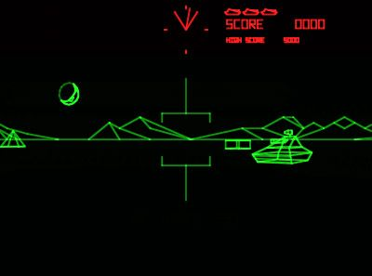

Figure . Battlezone Atari Inc. (Released 1980)

Today 3D rendered scenes can contain 10s of millions of polygons, thousands of dynamic light sources and complex material models. An extraordinary amount of research has been conducted to get us to the level of realism we have come to expect from 3D rendering today.

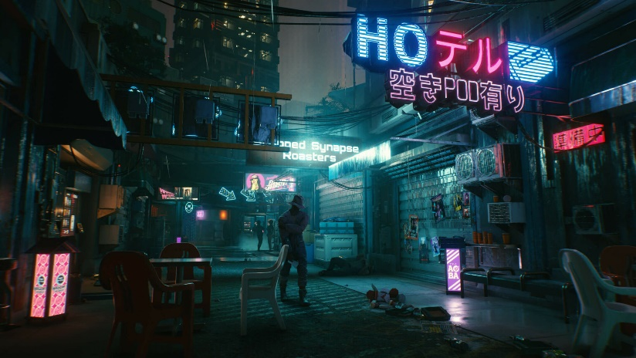

Figure . Cyberpunk 2077 CD Projekt RED (Released 2020)

Within computer graphics, there exists an upper echelon of computer graphics researchers whose work has significantly advanced the field of computer graphics and inspired me to pursue this project.

Brent Burleys 2012 paper on physically-based rendering, followed by Brian Karris' presentation on adapting these techniques for real-time rendering, kickstarted a transformation in how 3D shading is performed. After these publications, many real-time rendering engines began to move away from Blinn-Phong shading models to shading models whose parameters are based on the physical properties of materials.

Ola Olsson, in his 2012 paper Clustered Deferred and Forward Shading, presented the techniques in use today by many rendering engines to optimise real-time rendering for scenes with many dynamic light sources. While Christoper Peters from the University of Bonn spearheaded developments into real-time techniques for rendering transparent materials.

The most prominent resource of my project has been Real-Time Rendering, 4th Edition by Akenine-Möller et al. This book is considered by many to be the encyclopedia of real-time computer graphics. Each chapter explores in detail the various techniques that have been discovered to perform 3D rendering tasks. While it does not contain implementation detail for these techniques, it summarises the pros and cons of each technique and guides the reader to consult the source material to realise these techniques in code.

My project sought to advance these resources by exploring how to link their functionality together to create a real-time 3D rendering engine.

# Rendering Engine Architecture

Before exploring the rendering techniques that I have implemented, I will present the underlying architecture of the rendering engine and some of its support systems.

## Introduction

Figure 3.1 details the layout of the rendering stages in my rendering engine. The black lines with arrows indicate the execution order of a frame. The black lines represent dependencies between the subsystems, e.g. light culling depends on the G-Buffer generation stage finishing before it can begin executing. Stages that appear above or below each other vertically indicate that these stages can occur concurrently, e.g. light culling, AO map generation, and the transparency absorbance pass can all take place concurrently.

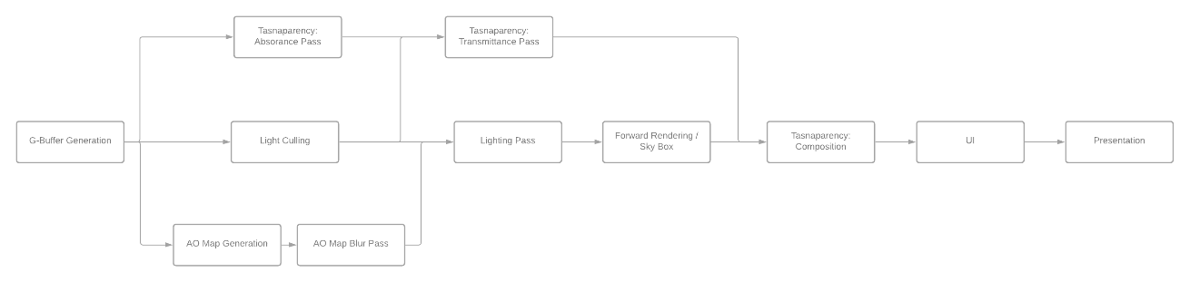

Figure . Rendering Engine Render Stages

## Scene Management

An essential part of any rendering engine is how to layout and manage the scene. As your scenes grow in complexity, it becomes very laborious to manually write code to submit individual meshes to the rendering engine and specify the shader pathways that the mesh will invoke. To overcome this, I implemented a scene management system based on an entity-component architectural pattern. This scene management system has three primary levels; first, there is the *GameObject* which represents an object in the scene, each game object can then have several components which represent a specific part of that GameObject, e.g. the mesh, a camera. Managing all these GameObects, we have the *Scene* object that holds all the required information about a scene. This greatly simplified scene management and allowed for a mesh to automatically invoke its required rendering pipeline once it was added to a scene.

### Game Objects

As mentioned previously, the GameObject class represents a single object in a scene. Essentially a GameObject contains its positions, rotation and scale in the scene and a list of all the different components that it owns.

A GameObject can also define a hierarchical relationship between itself and other GameObjects. i.e. A GameObject can have child GameObjects whose transformation information is defined relative to the parent GameObject. When the parent GameObject is transformed in some manner, the transformation effect will propagate down this hierarchy.

This dramatically simplifies scene layout as it allows an easy way to group together related GameObjects and makes it very easy to translate a group of GameObjects by just needing to translate the parent GameObject at the root of the hierarchy.

Although the name GameObject would suggest that its use is restricted to video games, this name is merely a standard convention that I encountered in many sources. The GameObject class does impose any restrictions on a user that would prevent its use in other 3D rendering settings.

### Components

A component system allows for great flexibility when designing a rendering engine. All components are created and managed by an owning GameObject.

All components inherit from a common interface, the *BaseComponent* interface.

The BaseComponent interface has the following methods:

* RegisterComponent
  + Allows the component to register itself with any systems that need to be aware of its existence in a scene. This method is called when the owning GameObject is added to a scene.
* UnregisterComponent
  + Like with RegisterComponent, this method allows the component to notify the relevant systems that it is no longer part of the scene. This method is called when the owning GameObject is removed from a scene.
* Update
  + As the name suggests, this method allows the component to implement any actions it needs to perform to update its state. This method is called only when the owning GameObject is updated as this prevents unnecessary invocations when its state has not changed since the last frame.

Each of these methods are defined as pure virtual functions that must be implemented by a class that inherits from the BaseComponent class. This allows for a very extensible and flexible system.

In my current implementation, I have several different components implementations, and I will now list a few of these components and the functionality they provide.

#### Mesh Component

The *MeshComponent* allows you to render a mesh in the location of the owning GameObject. It holds a reference to a mesh object that is loaded into the asset management system along with references to all the materials the mesh uses when rendering. The MeshComponent automatically registers itself with the rendering engine when its owning GameObject is added to the scene, allowing it to be rendered each frame. The MeshComponent also holds the bounding volume for the current mesh in local space and in world space which are utilised in the culling system that is discussed in a later section. A GameObject can have any number of mesh components, but typically a GameObject will only have a single mesh component.

#### Camera Component

The *CameraComponent* encapsulates all the parameters that are required for defining a camera for the rendering engine. By making the camera a component, we do not have to explicitly set its positions or direction as these values can be derived from the owning GameObject. Another benefit of defining cameras as components is that we can add many cameras to a scene with ease and then toggle between them to showcase different views of a scene quickly. A camera is composed of the view matrix, the projection matrix and a frustum volume that is utilised in the culling system.

#### Lights Components

In my rendering engine, I created two different light component types:

1. **Directional Lights**

Directional lights are a type of light defined only by the direction it shines in, its colour and its intensity. Directional lights model an infinitely distant light source where all rays of light are parallel, they are typically used in rendering to represent the sun or light reflecting off of the moon. Directional lights also have the unique property in that they do not model light intensity diminishing over a distance, so their intensity is constant over a scene (Unity Technologies, 2020).

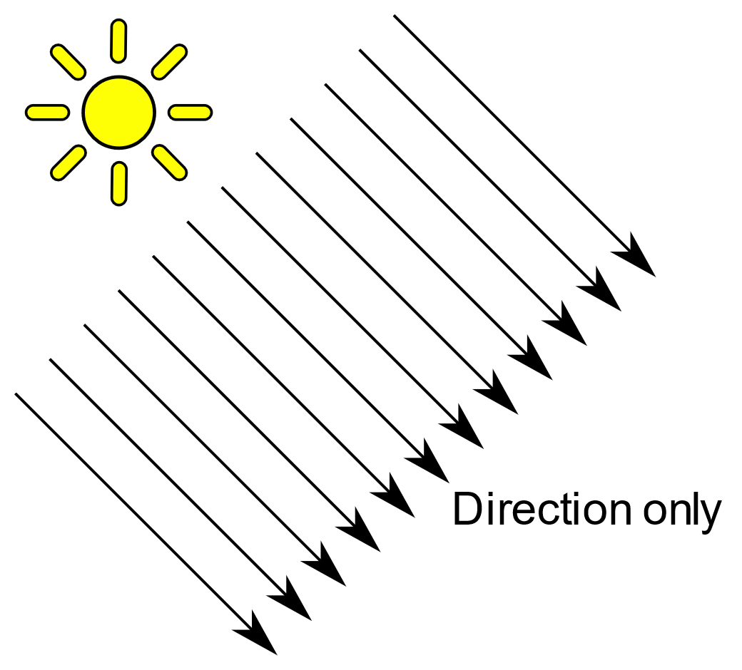

Figure . Example of parallel directional light rays

1. **Point Lights**

Points lights model a positional light source that shines light out equally in all directions around it. A point light is defined by its position, the light colour, and the initial light intensity. The light intensity from a point light on a surface is inversely proportional to the square of the distance from the point light to the surface. Point lights are typically used to model light bulbs in a scene. Point lights also have an optional parameter called range which defines a hard limit on the range of the light's effect. This offers more intuitive control over the area that a point lights affects rather than just adjusting the intensity parameter.

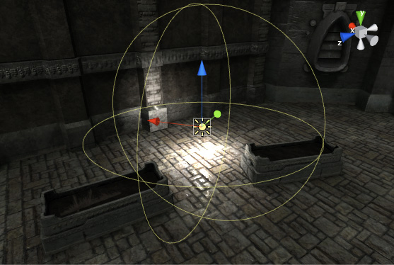

Figure . Point light source in the unity game engine

It would be very easy to implement a new form of light or mesh with this component system. For example, to support spotlights, all I need to do is implement a spotlight component class along with the shaders to utilise the spotlight, or if I wanted to add support for animated meshes, I could simply add an animated mesh component and the relevant systems.

### Scene

The Scene class hold all the information for a scene that is required by the rendering engine. It holds all the GameObjects in a scene, the environment map of a scene and the currently active camera. This allows for a scene to be quickly changed as all that is needed to change the scene is to provide the rendering engine with a different Scene object, and it will then render that scene.

The scene can be created manually by adding GameObjects to the scene, or they can be loaded from custom .scene files.

#### Scene File

The scene file allows for a scene to be authored in an external modelling software such as Maya, 3ds Max or Blender and then exported to the scene file format, which can then be loaded into the rendering engine. This allowed me to showcase far more complex scenes than I otherwise would have been able to. The .scene file format is a file format produced by a custom conversion tool that utilises the Open Asset Import Library (Assimp) to convert standard modelling software file formats such as FBX, OBJ, and Collada to my .scene file format, which is specifically formatted for my rendering engine. This greatly simplified the scene loading process as the engine only needs to directly support the .scene file format. This also allowed me to download reference scenes from the internet, such as the Amazon Bistro scene, and import them into my rendering engine with great ease.

The .scene file is a binary file format as this allows me to quickly load vertex data directly into vertex buffers instead of first needing to parse a text file that contains vertex data and then converting this text data into a format suitable to be stored in a vertex buffer. Similarly, .scene files store indices in such a way that they can be directly loaded into index buffers rather than requiring that they be parsed from a text file.

This .scene file provided a vast improvement on loads times once it was implemented. The Sponza scene with ~268,000 triangles and ~750,000 vertices took 7.8seconds to load and parse the original .obj file. After converting this to a .scene file, it now takes 830ms to load the scene, and 577ms of this load time is spent loading in texture files. It also reduced the file size when compared to the original .obj file, which was 21MB. The new .scene file is 11MB; however, this file size improvement is not always present. Compared with .fbx files, the files the file size grows when converted to the .scene file; however, load time efficiency is still gained compared to loading FBX files directly.

Another benefit of using a conversion tool and a custom scene format is that I can perform optimisations on meshes and materials ahead of time that improves the rendering engine's efficiency and load times. One example of this is texture packing. When using the PBR material model, each material must store its metallic values and roughness values in a texture. As these values are simple 8-bit numbers, we can combine the two textures and instead store the values on individual colour channels in the combined image, thus significantly reducing each material's memory footprint.

# Vulkan

The graphics API that I chose to use for this project is Vulkan. Vulkan is a “close to metal” graphics API that is well suited to high-performance applications such as real-time rendering engines.

## Introduction

Vulkan is a next-generation graphics API that is developed by the Khronos group. It is a highly efficient cross-platform API for modern GPUs that can be used for graphics rendering and general GPU computations. For this project, I focused mainly on 3D graphics rendering; however, compute shaders were employed to implement some rendering techniques such as clustered shading. Vulkan is supported on many platforms such as Windows, Linux, Android and the Nintendo Switch. By utilising a library called MoltenVK, you can provide support for macOS & IOS as this library provides Vulkan wrappers around Apples Metal graphics API (The Khronos Group, 2021).

Vulkan was first released in 2016, and while initial adoption was relatively slow due to the vast differences compared to the previous generation graphics API. Vulkan has started to gain more traction recently as game development studios and other real-time rendering applications have begun to learn how to effectively leverage Vulkan and the performance improvements that come with it. Vulkan is the successor API to OpenGL but follows a very different design philosophy than OpenGL. Vulkan exposes graphics hardware to the developer at a much lower level than with OpenGL. This has the effect of requiring a developer to explicitly describe every action they wish for the GPU to perform. Many responsibilities have also been shifted from GPU drivers to rendering engineers, such as CPU-GPU synchronisation and graphics pipeline creation. This has allowed developers to overcome previous challenges where differing driver implementations caused rendering engines to perform poorly on different hardware.

In the previous generation graphics APIs, only one thread could create rendering commands for the GPU. As CPUs evolved and thread counts began to increase instead of raw clock speed, this became a bottleneck as renderable scenes grew more complex and detailed. With Vulkan, there is a heavy focus on recording rendering commands from multiple threads at once. To allow this, Vulkan employs command buffers which are a structure that allow you to record rendering commands which are then submitted to the GPU. Rendering commands can be recorded on multiple threads and combined into a single command buffer that is then submitted to the GPU. Unlike in OpenGL, you must ensure that you do not attempt to write to any resource that the GPU is currently using. In the past, the GPU driver would work out a memory synchronisation solution to prevent the program from crashing. With Vulkan, you must explicitly record synchronisation commands to the GPU to place read/write guards around resources to prevent race conditions (Foley, 2015).

Due to how new the Vulkan API is, there is now yet an agreed set of best practices for many common operations, such as memory management, resource management and binding resources to the GPU. This provided an excellent opportunity for experimentation and allowed me to implement creative solutions to tackle these problems.

## Descriptor Management

In Vulkan, resources are submitting to GPU shaders through the use of descriptor sets (VkDescriptorSet). A descriptor is a shader variable that is used to access a buffer or an image. A descriptor can be thought of as a pointer to a resource. The Vulkan API allows these variables to be changed between draw calls. A descriptor set is a set because it can refer to an array of resources that are described with the same layout binding (LunarG, Inc, 2016). A layout binding describes the resource binding slots for a GPU shader.

Descriptor sets are created from a descriptor pool which specifies the maximum amount of each resource that it can allocate descriptors for. For example, a descriptor pool might allow ten textures but only one uniform buffer. It is very tedious to manage these descriptor pools manually and to decide on the correct allocation limits. Along with this, descriptor pools are not thread-safe, so each thread needs to have its own descriptor pool.

As such, every Vulkan application will have to create a system for managing these descriptor sets. When rendering static scenes, you can preallocate all the descriptor sets you will need however this is very limiting. When rendering dynamic scenes, a basic strategy is to recreate every descriptor set you need each frame. However, this is very inefficient (Provenzano, 2019). There is also a level of overlap between resources bound to the GPU when rendering; for example, if two meshes share the same material, it would be wasteful to allocate two separate descriptor sets for identical resources. An ideal solution would be to have a system that allows the same descriptor set to be used by all meshes that use a particular material.

To overcome these issues, I developed a descriptor set caching system, *DescriptorSetManager*, which manages the allocation and sizing of the descriptor pools along with the allocation and caching of descriptor sets. Descriptor sets can be categorised by how often they are updated, e.g. once per scene, once per frame, once per mesh, once per material. We can use the object that supplies the updated data as a key into a hashmap to cache the descriptor set so that it can be reused. i.e. use the material as a key, and every time we need a descriptor set for that material, we can look it up in the hash map. Each rendering pipeline has its own descriptor set cache manager as different pipelines will use different binding location to the GPU shaders for different descriptor sets. This greatly simplified the task of creating graphics pipelines and binding resources to them. The DescriptorSetManager allows for a much smoother developer experience when implementing various rendering techniques.

## Memory management

In the previous APIs like DirectX11 and OpenGL, GPU memory management was handled automatically by the API. You would create a resource and the API would allocate the memory backing that resource for you (Sawicki, 2018). In Vulkan, this is no longer the case, and instead, you must manually allocate the memory for every resource yourself.

Allocating memory in Vulkan requires that you first query the GPU for your requested memory type, i.e. if you want to allocate memory that is only visible to the GPU (DEVICE_LOCAL), memory that is visible to only the CPU (HOST_VISIBLE) or memory that is visible to the GPU and the CPU (DEVICE_LOCAL + HOST_VISIBLE). After this, you must allocate the requested memory type and bind the memory to the resource. Although it is much more work, it opens up a few advantages to developers, such as being able to layout memory in a specific way that is optimal for a specific platform, and you can allocate related resources closely together in memory for faster access speed.

Allocating memory also presents another challenge in that Vulkan restricts you to a maximum of 4096 active memory allocations at any one time (Halladay, 2017). This restriction is not unique to Vulkan and was also present in the previous generation graphics APIs; however, it was masked by the automated memory management system that they employed. To overcome this limitation, we must instead allocate large blocks of memory at one time, typically 256MB blocks of memory and then sub allocate memory from these blocks for our resources to occupy. Performing this task manually is quite a complex task, and it is easy to make mistakes. To overcome this, developers typically create or use a custom memory management system.

In my case, I utilised the GPUOpen framework, Vulkan Memory Allocator. Vulkan Memory Allocator (VMA) is a memory management framework initially developed by AMD but later open-sourced that handles allocating blocks of memory and sub allocating memory for resources in these blocks. VMA also has helper functions that will create the resources for you and bind the memory to them in one call. After switching from manual memory management to VMA, I gained a 10% increase in frame times. It also allowed me to create much more memory intensive resources, such as my Amazon Bistro scene with over 1 million triangles and 70 different materials.

Vulkan memory management can be further improved by allocating related resources into a single buffer that occupies one memory block. An example of this is allocating a vertex buffer, index buffer and uniform buffer for a mesh into a single buffer which will significantly improve cache coherency in the GPU as the related resources will be in the same memory blocks. This will help avoid costly cache misses from having to load memory locations that are physically distant from each other on the VRAM chip.

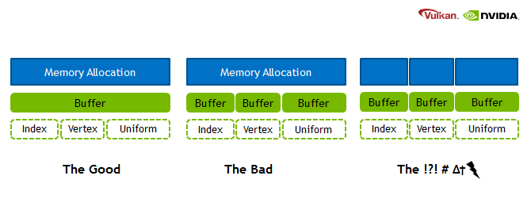

Figure . Nvidia recommended memory layout strategies (Hebert, 2016)

# Physically-Based Rendering

Following on from my Vulkan implementation, I implemented a modern material shading system. As almost all modern rendering engines implement a physically-based shading system, I studied and implemented this technique in my project.

## Introduction

Physically-based rendering or PBR is an approach to rendering that renders materials using the physical properties of lights and materials based on real-world values rather than artistic parameters.

In real-time applications such as games, it is not possible to achieve an exact physical representation of materials like what is done in the movie industry as it is too computationally expensive. Instead, we utilise approximations that still produce realistic and visually pleasing results.

For a PBR shading model to be considered physically based, it must satisfy the following three conditions: (Learn OpenGL, 2016)

1. Be based on the microfacet surface model;
2. Be energy-conserving; outgoing light energy should never exceed the incoming light energy (excluding emissive surfaces);
3. Use a physically based BRDF.

Physically-based rendering requires an entirely different material and lighting system than the one traditionally used in Blinn-Phong shading. In Blinn-Phong shading, materials are be defined by the following parameters:

* **Ambient colour:** RGB value describing its ambient lighting colour;
* **Diffuse colour:** RGB value describing its diffuse lighting colour;
* **Specular colour:** RGB value describing its specular reflection colour;
* **Shininess exponent:** floating point exponent describing the shininess of the material.

None of these concepts have a physical basis in reality and are instead artistic parameters selected through quite a subjective process to create a desired material. This process also requires you to create a different material for different lighting conditions, such as a day/night cycle, to get a consistent look.

Lights sources are also be defined by artistic parameters rather than physical units, which further complicated the asset authoring pipeline. Sometimes, lighting details would be baked into material textures that limit their ability to be used in dynamics scenes.

One of the core principles of PBR is the decoupling of material and lighting information, this ensures visual consistency between all objects in a scene regardless of lighting conditions (Lagarde & Rousiers, 2014).

Two major workflows currently exist for physically based rendering, the metallic-roughness workflow and the specular-glossiness workflow. I chose to use the metallic-roughness workflow as most sources, both academic and practical, use metallic-roughness.

The metallic-roughness workflow exposes the following parameters for a material:

* **Albedo:** RGB value describing the colour of the material with no lighting information or if the surface is metallic it contains the base reflectivity of the material.
* **Metalness:** Floating point value ranging from 0.0 to 1.0. 0.0 represents a non-metallic surface and 1.0 represents a fully metallic surface. Values between these ranges are used to represent a metallic surface with surface imperfections such as a dust covering or rust.
* **Roughness:** Floating point value from 0.0 to 1.0 which describes the microgeometry's roughness, with 0.0 representing a perfectly smooth surface that will perfectly reflect incoming light, while values ranging up to 1.0 will cause the incoming light to scatter on contact.

These parameters are usually provided through texture maps with a mesh mapped to the textures through its UV vertex coordinates. Additionally, a normal map is also generally included, which describes per-pixel surface normals for a material.

## The Physics of Light

As physically-based rendering models an approximation of lights interaction with a material, it is important to define and understand some of the principles of the physics of light. Light or visible light is electromagnetic radiation within the portion of the electromagnetic spectrum that can be perceived by the human eye (Wikipedia, n.d.). Light waves are emitted when the electrical charges in an object oscillate. Part of the energy that caused the oscillations—heat, electrical energy, chemical energy—is converted to light energy that is radiated away from the object. In rendering, such objects are treated as light sources (Akenine-Möller, et al., 2018).

In physically-based rendering, we model a light's interaction with surface irregularities that are in the size range of 1 – 100 wavelengths. We focus on this range as surface irregularities smaller than 1 wavelength have no effect on light, and surface irregularities larger than 100 wavelengths effectively tilt the surface rather than affecting its local flatness. To translate this into rendering terms, surface irregularities much larger than a wavelength change the local orientation of the surface (Akenine-Möller, et al., 2018).

When light strikes a surface point, it is reflected in a specific direction by that surface point; however, in rendering, each pixel represents several surface points that reflect light in various directions. To calculate the final appearance of a pixel, we need to aggregate the results of all these different reflection directions. Rather than modelling this explicitly, we treat it statistically and view the surface as having a random distribution of surface normals. As a result, we model the surface as reflecting and refracting light in a continuous spread of directions. The width of this spread, and thus the blurriness of reflected and refracted detail depends on the surface roughness (Akenine-Möller, et al., 2018).

When light is refracted, it continues to interact with the inner volume of an object. For metallic objects, most incident light is reflected, and the rest is absorbed. However, non-metallic objects exhibit a wide variety of scattering and absorption behaviours (Akenine-Möller, et al., 2018). Materials with low scattering and absorption are transparent, allowing all refracted light to travel through the object. While in opaque objects, light undergoes several scattering and absorption events until some of it is re-emitted back from the surface. This is known as subsurface scattering.

The subsurface scattered light exits the surface at varying distances from its entry point. The distribution of the entry-exit distances depends on the scattering properties of the material. If the entry-exit distances are small compared to the distance between shading samples, they can be assumed to be effectively zero for shading purposes, allowing subsurface scattering to be combined with surface reflection into the local shading model, with outgoing light at a point depending only on incoming light at the same point. However, since subsurface-scattered light has a significantly different appearance than surface reflected light, we divide them into separate shading terms. The specular term models surface reflection, and the diffuse term models local subsurface scattering (Akenine-Möller, et al., 2018).

If the entry-exit distances are large compared to the distance between shading samples, then specialised rendering techniques are needed to model the visual effect of light entering the surface at one point and leaving it from another (Akenine-Möller, et al., 2018).

## Microfacet Theory

Physically-based rendering techniques base themselves on the microfacet theory. Microfacet theory is the mathematical analysis of the effects of microgeometry on the reflectance of a material. (Akenine-Möller, et al., 2018). This theory describes that any surface at a microscopic scale can be described by tiny perfectly reflective mirrors called microfacets (Learn OpenGL, 2016).

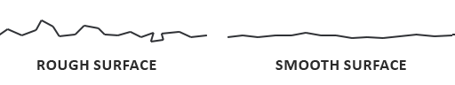

Figure . Microfacet example (Learn OpenGL, 2016)

The roughness of a surface changes the orientation of these mirrors and thus causes light to scatter along a variety of directions on rougher surfaces, resulting in a more widespread specular reflection. In contrast, smooth surfaces will reflect light in the same direction across the surface giving rise to a smaller and sharper specular reflection (Learn OpenGL, 2016).



Figure . Microfacet light scattering example (Learn OpenGL, 2016)

## The BRDF

A material model, also known as a Bidirectional Scattering Distribution Function (BSDF), can be decomposed into two parts: A Reflectance part, the Bidirectional Reflectance Distribution Function (BRDF), and a Transmittance part, the Bidirectional Transmittance Distribution Function (BTDF).

This chapter will focus on the BRDF as translucence materials will be explored in a later chapter.

The BRDF forms part of what is known as the rendering equation (Equation 5.1). Where $f_{r}\left(x, ω_{i}, ω_{o}, λ, t\right)$ represents the BRDF.

$$L_{o}\left(x, ω_{o}, λ, t\right)= L_{e}\left(x, ω_{o}, λ, t\right)+\int_{Ω}{f_{r}\left(x, ω_{i}, ω_{o}, λ, t\right)L_{i}(x, w_{i}, λ, t)(ω_{i}⋅n)dω_{i}}$$

Equation . The Rendering Equation

The Cook-Torrance BRDF is a function that can be plugged into the rendering equation in place of $f_{r}$. With this BRDF, we model light's behaviour in two different ways, distinguishing between diffuse reflection and specular reflection, providing an individual BRDF for each term (CodingLabs.net, n.d.).

The diffuse BRDF models the local scale subsurface scattering for dielectric materials; it is ignored for metallic objects as metallic objects do not refract light and thus have no diffuse reflection (Learn OpenGL, 2016).

The specular BRDF models the specular reflection of a material as defined by the Cook-Torrance approximation (Equation 5.2).

$$f\left(l, v\right)= \frac{D(h)F(v, h)G(l, v, h)}{4 (n⋅l)(n⋅v)}$$

Equation . Cook-Torrance Approximation (Karis, 2013)

This BRDF is composed of three functions and a normalisation factor. These are defined as the Normal **D**istribution function, the **F**resnel equation and the **G**eometry function (Learn OpenGL, 2016):

* **Normal distribution function:** This approximates the amount that the surface's microfacets align with the halfway vector (a unit vector at half-angle between the view direction vector and light direction vector). It is influenced by the surface's roughness. It is the primary function approximating the surface microfacets.
* **Fresnel equation:** The Fresnel equation describes the ratio of surface reflection at different viewing angles.
* **Geometry function:** This describes the self-shadowing property of the microfacets. When a surface is relatively rough, the surface's microfacets can overshadow other microfacets reducing the amount of light that the surface reflects.

We integrate the BRDFs over all relevant light sources to arrive at the final colour value of a surface material.

## Direct Lighting Implementation

I will now cover my implementation of calculating the effect of direct light sources on a material.

### Shaders

The shaders, written in GLSL, first require me to define a material system that accepts the following material parameters:

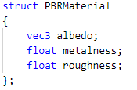

Code Sample . PBR material parameters

I grouped my PBR lighting calculations into a single function, CalculateDirectLighting, which takes in the material parameters along with the view vector, light vector and surface normal. Although it is considered bad practice to use single-letter variable names, for my PBR shader code, I chose to use a naming convention that matches the commonly used mathematical notation for formulating BRDFs as this made the link between the equations and code much clearer.

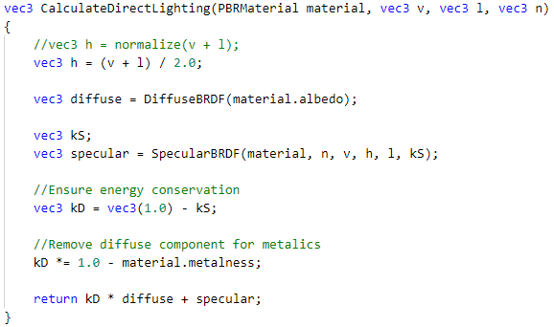

Code Sample . Direct lighting calculation shader function

### The Diffuse BRDF

For the diffuse BRDF I explored a couple of options. In his paper, Real Shading in Unreal Engine 4, Brian Karis from Epic Games compares Lambertian diffuse (Equation 5.3) to Disney diffuse (Equation 5.4), presented by Brent Burley from Disney (Burley, 2012) and concludes that there are only minor visual differences between the two thus making Disney diffuse not worth the extra computational cost and that Disney diffuse leads to added challenges when incorporating image-based lighting.

$$f\left(l, v\right)= \frac{c_{diff}}{π}$$

Equation . Lambertian Diffuse

Equation . Disney Diffuse (Burley, 2012)

However, Sébastien Lagarde & Charles de Rousiers from Dice concluded in their paper, Moving Frostbite to Physically Based Rendering (Lagarde & Rousiers, 2014), that this conclusion is incorrect and leads to a disconnect with the specular reflection of the object as the roughness of the surface has not been taken into account. They concluded that Disney Diffuse is the correct solution.

In his presentation about physically based rendering at Ubisoft (McAuley, 2019), Stephen McAuley stated that they also used simple Lambertian diffuse until 2018. Going off of all this information, I felt that the simple implementation of Lambertian diffuse was a good compromise between performance and correctness.

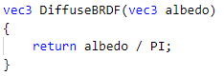

Code Sample . Lambertian diffuse implementation

### The Specular BRDF

For the specular BRDF, I utilised the Cook-Torrance BDRF approximation (Equation 5.2) as all sources I came across show that this is a well-entrenched industry standard. To begin, I followed the implementation and techniques set out by Brian Karis (Karis, 2013) to start me off.

Each component of the numerator offers different techniques with varying results. Brian Karis put together a list (Karis, 2013) of the various options available and elaborated on the benefits of each option. I used this resource to pick the appropriate implementation for each component.

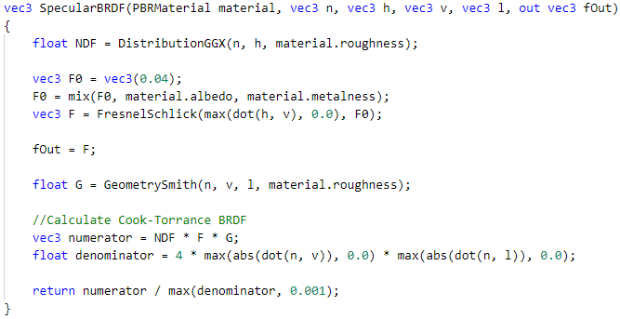

Code Sample . Cook-Torrance BRDF shader function

### The Normal Distribution Function

For the Normal Distribution Function, Karis concluded that Disney use of GGX/Trowbridge-Reitz (Equation 5.5) presented by Burley to be an ideal candidate as it produces a natural appearance due to the longer "tail" that it produces for the specular reflection. $α$ here corresponds to the roughness of the surface, while $h$ refers to the halfway vector between the surface normal and the light direction.

$${NDF}_{GGXTR}\left(n, h, α\right)= \frac{α^{2}}{π{({\left(n⋅h\right)}^{2}\left(α^{2}-1\right)+1)}^{2}}$$

Equation . GGX/Trowbridge-Reitz (Learn OpenGL, 2016)

When roughness is low, a highly concentrated number of microfacets are aligned to the halfway vector over a small radius. Due to this high concentration the NDF displays a very bright spot. On a rough surface where microfacets are aligned in much more random directions, the microfacets align with the halfway vector in a much lower concentration thus producing greyer flatter results (Learn OpenGL, 2016).

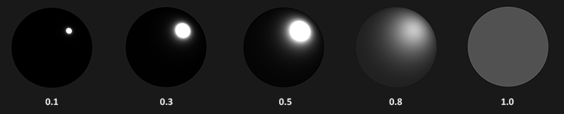

Figure . Effects of NDF as roughness increases (Learn OpenGL, 2016).

This resulted in the following implementation:

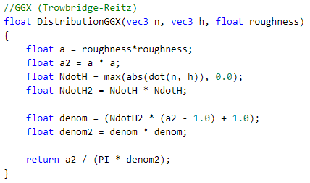

Code Sample . GGX/Trowbridge-Reitz implementation

### Fresnel Reflection

For the Fresnel reflection, the industry standard is the Schlick approximation.

$$F_{Schlick}\left(h, v, F_{0}\right)= F_{0}+(1-F_{0}){(1-(h⋅v))}^{5}$$

Equation . Fresnel reflection Schlick approximation (Learn OpenGL, 2016)

In this equation $F_{0}$ represents the base reflectivity of the surface, which is calculated using the materials index of refraction. There are a few caveats to the Schlick approximation; the first is that the equation is only really defined for dielectric materials. For conductors (metals), calculating the base reflectivity with indices of refraction does not correctly hold, and instead, we would need to use a different Fresnel equation.

As this is inconvenient, we further approximate the equation by pre-computing the surface's response at normal incidence ($F_{0}$) at a 0-degree angle as if looking directly onto a surface. We interpolate this value based on the view angle, as per the Fresnel-Schlick approximation, allowing us to use the same equation for both metals and non-metals. However, we need to tint the base reflectivity for a metallic surface to achieve realistic results (Learn OpenGL, 2016).

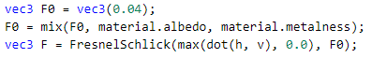

Code Sample . calculation

To simply things, most rendering engines define a base reflectivity that is averaged around most common dielectrics. This is usually 0.04. However, a potential improvement would be to expose this parameter to be configurable, although this does not seem to be common practice at the time of writing.



Code Sample . Fresnel-Schlick approximation implementation

### Geometric Attenuation (Geometry Function)

The geometric attenuation function approximates the relative surface area where its micro surface details overshadow each other causing light rays to be occluded. This is based on the roughness parameter of a surface's material (Learn OpenGL, 2016).

The geometry function that I used is a combination of the GGX and Schlick-Beckmann approximation known as Schlick-GGX (Equation 5.7).

$$G_{SchlickGGX}\left(n, v, k\right)=\frac{n⋅v}{\left(n⋅v\right)\left(1-k\right)+k}$$

Where *k* is a remapping of roughness according to

$$k=\frac{{(Rougness+1)}^{2}}{8}$$

Equation . Schlick-GGX (Karis, 2013)

This remapping was put forward by Burley in his Disney PBR paper, as it reduced perceived "hotness" and was more usual for artists (Karis, 2013).

To effectively approximate the geometry, we need to consider both the view direction (geometry obstruction) and the light direction vector (geometry shadowing). We can take both into consideration by using Smith's method (Learn OpenGL, 2016):

$$G\left(n, v, l, k\right)=G_{sub}(n, v,k)G_{sub}(n,l,k)$$

Equation . Geometric Attenuation: Smith Method

This lead to the following implementation:

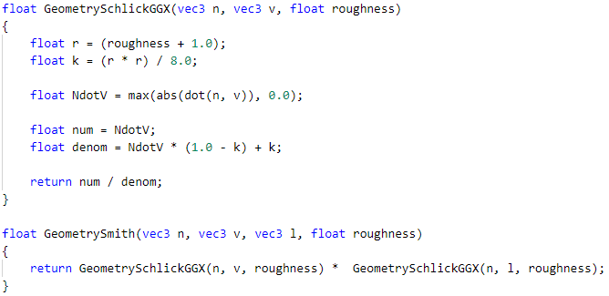

Code Sample . Geometry attenuation smith method implementation

### Energy Conservation

After calculating the results of the diffuse BRDF and the specular BRDF, there a couple of more steps you must undertake to ensure that you comply with the laws of physics.

We need to ensure that our BRDF is energy conserving and does not emit more light than it has received, except in the case of emissive surfaces. We do this by calculating the ratio that our diffuse BRDF and specular BRDF contributes to the reflectance equation and ensure that their combined ratio is not above 1.0. kS here is equal to the Fresnel value of our specular BRDF as this gives us the ratio of specular light for a surface.

Secondly, because metallic surfaces do not refract light, we must disregard or further scale the diffuse component if the material is metallic.

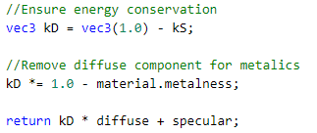

Code Sample . Energy conservation shader calculation

### Results

Below is the result of applying the direct lighting BRDFs to an array of spheres with a base albedo of RGB(255, 0, 0), i.e. Red, with metalness increasing along the X-axis in increments of 0.2 and roughness increasing along the Y-axis in increments of 0.2. Notice the lack of diffuse lighting in the bottom left on the fully metallic material with 0 roughness and the growing specular highlight as roughness increases.

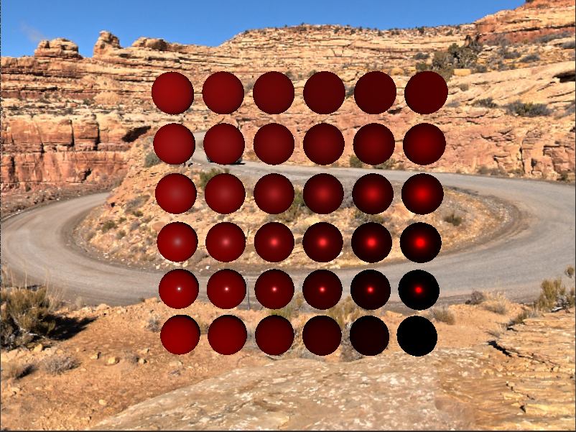

Figure . Results of applying direct lighting PBR BRDFs to a range of materials

## Indirect / Environment Lighting

When only modelling direct lighting, as seen in the previous results (Figure 5.4), you miss out on the significant visual improvements that PBR introduces, particularly so for metallic surfaces as they have no diffuse reflectance. With direct light alone, you do not get any interesting specular reflection, only a highlight of the colour of the light source. To correct this, I will now go over some techniques to model this environment light.

In the reflectance equation (Equation 5.9), there is no difference between a direct light source and indirect light sources. All incoming light sources have a radiance value, and the reflectance equation integrates over them (Akenine-Möller, et al., 2018).

$$L_{o}\left(p, ω_{o}\right)=\int_{Ω}{(k_{d}\frac{c}{π}+k_{s}\frac{DFG}{4\left(ω_{o}⋅n\right)\left(ω_{i}⋅n\right)})L_{i}(p, ω_{i})n}⋅ω_{i}dω_{i}$$

Equation . Cook-Torrance Reflectance Equation (Learn OpenGL, 2016)

The task, therefore, breaks down to how do we represent these radiance values for the overall environment of a scene. One approach, first presented by Karis (Karis, 2013), is to use a pre-processed HDR environment texture map which models each pixel of the texture as a light source. This technique is the pioneering technique for environment lighting and is used by many rendering engines. However, this technique is beginning to fall out of use as it is deemed to be too static for interactive environments, and it is not easy to source suitable texture maps (Lagarde & Rousiers, 2014). Instead, a growing trend is to develop a system to generate a physically-based sky and atmosphere that contains a vast amount of information about your environment such as: altitude, air composition, longitude, latitude, time of year and weather effects, which all contribute to the final lighting (Unity Technologies, n.d.). As this is a very advanced technique, I chose Karis' image-based lighting technique using environment maps. This is a good baseline to work from and still produces visually pleasing results with a physical basis.

### Environment Map / Image-Based Lighting

Solving the reflectance integral requires you to sample an environment map from all possible directions $ω_{i}$ over the hemisphere $Ω,$ which is far too expensive to do in real-time (Learn OpenGL, 2016). To overcome this, we pre-compute as much of the integral as we can and store this data in separate texture maps that will be sampled to retrieve the information.

Like with direct lighting, the reflectance equation (Equation 5.10) can be split into induvial components for diffuse and specular lighting.

$$L_{o}\left(p, ω_{o}\right)=\int_{Ω}{(k_{d}\frac{c}{π})L_{i}(p, ω_{i})n}⋅ω_{i}dω_{i}+\int_{Ω}{(k_{s}\frac{DFG}{4\left(ω_{o}⋅n\right)\left(ω_{i}⋅n\right)})L_{i}(p, ω_{i})n}⋅ω_{i}dω_{i}$$

Equation . Cook-Torrance Reflectance Equation Split into Diffuse Component and Specular

If we assume *p* is the centre of the environment map, then for diffuse lighting, this gives an integral that only depends on the direction $ω_{i}$ as the diffuse lambert term is constant (the colour c, the refraction ratio $k_{d}$, and $π$ are constant over the integral) (Learn OpenGL, 2016).

Knowing this, we can precompute a new cube map known as the irradiance map, that for each sample direction $ω_{o}$ stores a precomputed sum of all indirect diffuse light of the scene hitting some surface aligned along a direction. The result of this can be seen below.



Figure . Irradiance map

For the specular component, we are not so lucky and instead, the integral depends on the incoming light direction and the incoming view direction. Epic Games' split sum approximation (Equation 5.11) solves this by splitting the pre-calculation into two individual parts that we can later. The split sum approximation splits the specular integral into two separate integrals:

$$L_{o}\left(p, ω_{o}\right)=\int_{Ω}{L_{i}\left(p, ω_{i}\right){dω}_{i}*} \int_{Ω}{f_{r}\left(p,ω_{i},ω_{o}\right)n⋅{ω_{i}dω}_{i}}$$

$$f_{r}\left(p,ω_{i},ω_{o} \right)=\frac{DFG}{4\left(ω_{o}⋅n\right)\left(ω_{i}⋅n\right)}$$

Equation . Split sum approximation

The first term, when precalculated, is stored in what is known as the pre-filtered environment map. This is similar to the irradiance map, but we take roughness into account. For increasing roughness levels, the environment map is convolved with more scattered sample vectors, creating blurrier reflections. For each roughness level we convolve, we store the sequentially blurrier results in the pre-filtered map's mipmap levels.

The sample vectors and their scattering amount are generated using the normal distribution function of the Cook-Torrance BRDF that takes a normal and view direction as input. Epic Games makes a further approximation to the integral by assuming the view direction to be equal to the output sample direction $ω_{o}$. The effect of this is that we do not get grazing specular reflections when looking at specular surface reflections from an angle. This is, however, generally considered an acceptable compromise (Learn OpenGL, 2016). Karis points out that this is the largest source of error and break from reality in imaged based lighting (Karis, 2013).

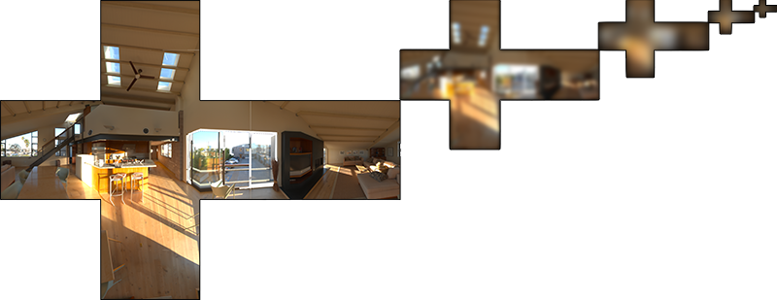

Figure . pre-filtered environment map (Learn OpenGL, 2016)

The second term of the split sum approximation is the BRDF part of the specular integral. This is the same as integrating the specular BRDF with a solid-white environment (Karis, 2013), we store the response of the BRDF as a 2D lookup table in a texture known as the BRDF integration map.

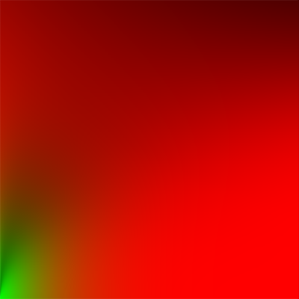

Figure . BRDF integration map (Learn OpenGL, 2016)

This integration map is constant across all environment maps; therefore, it can be calculated once and reused for any environment map.

Both the pre-filtered environment map and the BRDF integration map can then be combined in a shader to calculate the specular integral.

### Calculating the Environment Light Contribution

To calculate the indirect lighting contribution for a surface material, we need to sample the following three generated textures.

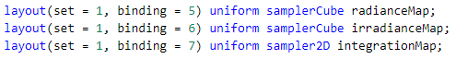

Code Sample . Environment lighting texture map shader bind points

As the irradiance map holds all of the scene’s indirect diffuse light, we sample this irradiance map along the surface normal and combine the value with the material albedo to get the diffuse portion of the indirect light

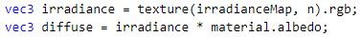

Code Sample . Environment light diffuse lighting calculation

Like with direct lighting, we must still scale this diffuse light according to the specular light contribution so that we obey the laws of energy conservation.

To do this, we use a modification of the Fresnel-Schlick equation used for indirect lighting. Before, we used cos of the angle between the half vector and the surface normal as input; however, in this case, we do not have a single half vector as we are receiving indirect light from all direction in a hemisphere orientated around the surface normal so instead we use the cos of the angle between the view vector and the surface normal. We also need to inject the roughness value of the material into this modified equation so that we can lower the surfaces reflective ratio (Learn OpenGL, 2016). i.e. rough surfaces will have softer reflections along their edges.

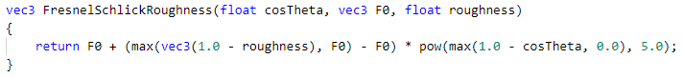

Code Sample . FresnelSchlick approximation with roughness taken into account for environment lighting

The result of the Fresnel- Schlick equation gives us the ratio of specular light that the surface is receiving. Like before, we can then work out the ratio to apply to the diffuse light. Also, like with direct lighting, we disregard/scale the diffuse lighting for metallic surfaces.

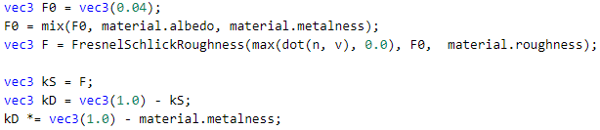

Code Sample . Energy conversion calculations for environment-based lighting

To calculate the specular lighting contribution, we sample the pre-filtered environment map (radiance map) along the reflection vector of the surface normal. We also sample an appropriate mip level of the radiance map based on the surface roughness, which will give rougher surfaces blurrier specular reflections (Learn OpenGL, 2016).

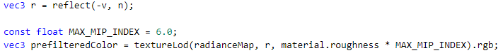

Code Sample . Sampling the radiance map according to surface roughness value

We then sample the BRDF integration lookup texture given the surface roughness and the angle between the normal and view vector.

With this value, we can work out the specular component of the environment lighting by multiplying it with the radiance map sample, Fresnel value and the sample of the integration map.



Code Sample . Calculating the specular BRDF for environment lighting

To get the total indirect lighting contribution, we add the diffuse and specular components together with the diffuse component scaled by the diffuse lighting ratio.



Code Sample . Total environment lighting contribution

Finally, to get the final lighting value of a surface, we combine the direct lighting contribution with the indirect lighting contribution to give the pixel its colour.

These environment lighting techniques then need to be combined with other global illumination techniques such as reflections, shadows and ambient occlusion to arrive at the final representation of a material in a scene.

## Results

Below are the final results of applying physically based rendering techniques to different material parameters. In Figure 5.8, the surface metalness increases along the X-axis and the surface roughness increases along the Y-axis, giving an overview of the result of the BRDFs with different material parameters. This presents a huge contrast to the direct lighting example and highlights the importance of environment light and reflections for metallic materials.

 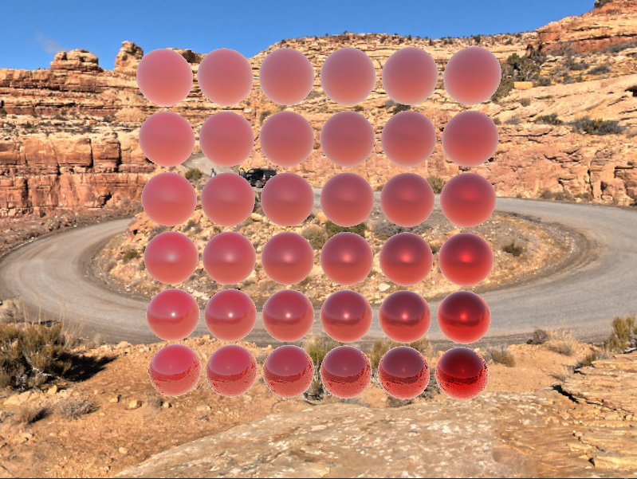

Figure . Results of PBR shading. Left: Excluding environment light. Right: Including environment light.

# Rendering Systems

To allow my physically based rendering shading model to shade a complex scene, I needed to develop systems to improve the efficiency of processing many light sources in a single frame.

## Deferred Shading

Deferred shading is a technique used to support a very large number of lights in a scene. In a typical forward shading architecture, you render an object and calculate its surface colour according to all lights in the scene, and you repeat this process for every object in the scene. Forward rendering on its own can be quite wasteful in highly complex scenes as fragment shader output can be overwritten when objects overlap, thus wasting the time we spent on the lighting calculations for that fragment (Learn OpenGL, 2016).

Deferred shading, on the other hand, involves performing all visibility tests and surface property evaluations before performing any material lighting computations (Akenine-Möller, et al., 2018). This surface property evaluation involves writing basic attributes of the mesh such as the position, normal and PBR material properties of an object to full screen render targets. These render targets, collectively known as the G-Buffer, hold these surface properties and correspond pixel to pixel to the final render target. This stage of generating the G-Buffer is known as the geometry pass. After the G-Buffer is generated, we invoke a lighting pass that reads in the G-Buffer values as inputs into our PBR BRDFs for each pixel and outputs the final colour of the pixel. This essentially changes the complexity of rendering a scene from $O\left(geometry*lights\right)$ to $O\left(geometry+lights\right)$ (Neverender, 2010).

For traditional forward rendering, the vertex and fragment shader programs retrieve each light's and material's parameters and computes the effect of one on the other. Forward shading needs either one complex vertex and fragment shader that covers all possible combinations of materials and lights, or shorter, specialised shaders that handle specific combinations. Long shaders with dynamic branches often run considerably slower, so a large number of smaller shaders can be more efficient, but they also require more work to generate and manage. Since all shading functions are done in a single pass with forward shading, it is more likely that the shader will need to change when the next object is rendered, leading to inefficiency from swapping shaders (Akenine-Möller, et al., 2018).

Deferred shading allows a strong separation between lighting and material definition. Each shader is focused on parameter extraction or lighting, but not both. Shorter shaders run faster, both due to length and the ability of the GPU to optimise them. The number of registers used in a shader determines occupancy, a critical factor in how many shader instances can be run in parallel. This decoupling of lighting and material also simplifies shader system management. For example, this split makes experimentation easy, as only one new shader needs to be added to the system for a new light or material type instead of one for each combination (Akenine-Möller, et al., 2018).

Deferred shading is not without its downside. Two important technical limitations of deferred shading involve transparency and antialiasing. Transparency is not supported in a basic deferred shading system since we can store only one surface per pixel. One solution is to use forward rendering for transparent objects after the opaque surfaces are rendered with deferred shading. An advantage of forward shading methods is that antialiasing schemes such as MSAA are easily supported. Forward techniques need to store only N depth and colour samples per pixel for N × MSAA. Deferred shading could store all N samples per element in the G-buffers to perform antialiasing, but the increases in memory cost, fill rate, and computation make this approach expensive (Akenine-Möller, et al., 2018). To overcome this antialiasing problem, you can instead utilise other antialiasing techniques such as FXAA as a post-process on your final rendered image. Deferred shading also has a considerable impact on VRAM usage. Although this is less of an issue on modern GPUs, which typically have 4GB+ of VRAM

### The G-Buffer

As mentioned previously, the G-Buffer is a collection of textures that store model data that is used as input into the lighting pass. A simple G-Buffer layout for a PBR rendering pipeline would contain the following properties:

* A 3D vector representing world position;
* A 3D normal vector representing the surface normal in world space;
* RGBA albedo colour;
* Metalness value;
* Roughness value.

This is how such a G-Buffer layout would look in memory:

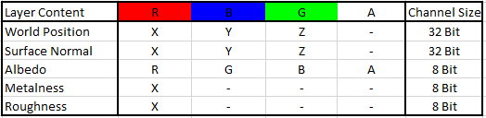

Figure . Basic G-Buffer

As you can see, this is exceptionally wasteful as we have a lot of empty channels in our render targets. For a render target size of 1920 * 1080 (1080p), this would take up over 87MB of VRAM, and for 4K resolution, this would be over 350MB.

An immediate optimisation that can be seen is to pack the metalness and roughness parameters into the same render target but onto different channels. Another optimisation that is not so obvious is that the world position layer is redundant as the world position can be reconstructed from the scene's depth buffer.

The world position can be reconstructed by reversing the process by which the depth value was calculated. Given the screen position and depth value, we first convert the screen position from NDC space to Clip space by remapping it from [0 -> 1] to [-1 -> +1]. Plugging the depth value in as the Z coordinate of the clip space, we can convert to view space by multiplying this position by the inverse projection matrix and then performing the perspective divide. To get to world space, we multiply this view space coordinate by the inverse of the view matrix.

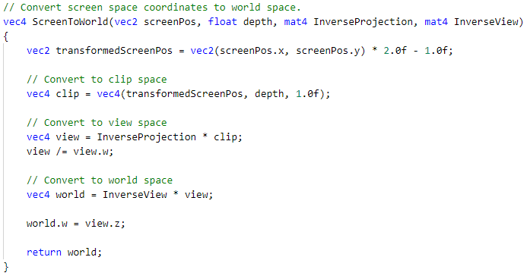

Code Sample . World position reconstruction from using depth buffer value

By utilising these optimisations, we can roughly half the G-Buffer's memory requirements, which has the resulting layout:

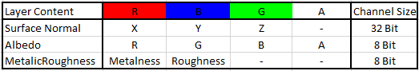

Figure . Optimised G-Buffer

The memory requirements for this layout are now 47MB for 1080p and 189MB for 4K. This is still a rather basic G-Buffer compared to most modern implementations; however, it serves its purpose for this project and can be easily expanded on as needed by other techniques.

Figure 6.3 shows an example of the G-Buffer used by Ubisoft in the video game Rainbow 6 Siege.

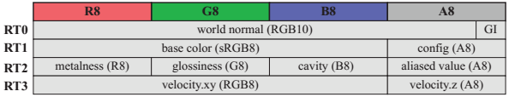

Figure . An example of a possible G-buffer layout used in Rainbow Six Siege. In addition to depth and stencil buffers, four render targets (RTs) are used as well (Akenine-Möller, et al., 2018).

### Geometry Pass Implementation

To perform the geometry pass of my deferred rendering implementation, we need to create a separate Vulkan graphics pipeline per mesh type and material combination. For example, in my case, I created a pipeline to accept static meshes with PBR parameters specifying its materials.

Creating the G-Buffer is relatively simple and involves just writing the required properties of the mesh material combo to the G-Buffer frame buffers in the fragment shader.

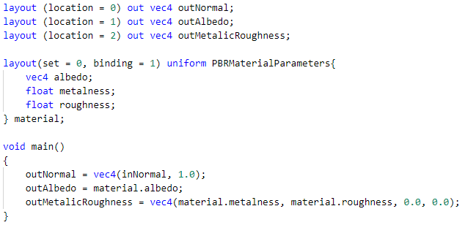

Code Sample . Geometry pass fragment shader for static meshes with PBR parameter material

The resulting G-Buffer would appear as follows:

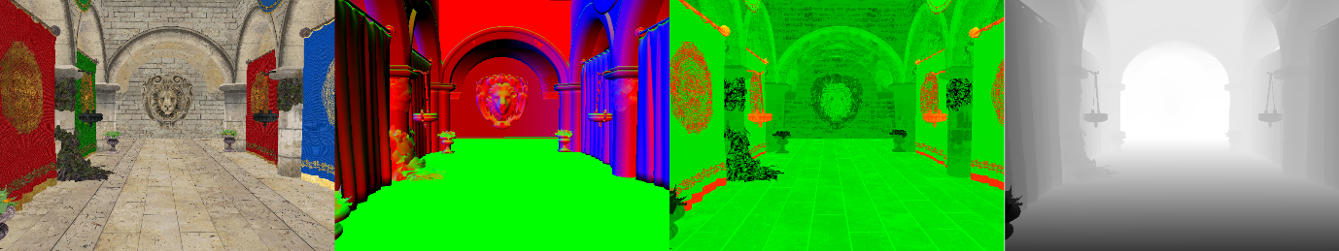

Figure . G-Buffer contents after geometry pass, from left to right: albedo layer, surface normal layer, metallic-roughness layer and dept buffer of Sponza scene (in-engine).

### Lighting Pass Implementation

For the lighting pass, we just need a separate pipeline per light type. I support three different light sources: point lights, directional lights and environment light.

Each of these light shaders takes in the G-Buffer as input and use its content to calculate the result of the PBR BRDFs. In basic deferred shading, we utilise one draw call per light and blend the results into the final render target. This allows us to only need to calculate the PBR BRDF once per light per pixel.

This alone will allow a large number of lights in a scene, but it is quite wasteful as the light shaders are executed on every pixel even if the light turns out to have no effect on the surface at that pixel. To further improve performance, we can utilise light culling techniques to reduce the number of lights that we attempt to use to shade a material.

## Compute Shaders

Before discussing my various techniques for determining the number of lights that affect a material, it is important to understand how computer shaders work, as they are used quite heavily in the following sections. Compute shaders are a shader stage in the GPU pipeline that are used for computing arbitrary information. Compute shaders are well suited to simple calculations that can be massively parallelised (Khronos Group, n/a). Compute shaders execute in dispatch groups, a dispatch group represents a group of threads in the GPU. Within these groups, you reserve a number of threads that is multiple of 32 for Nvidia GPUs or 64 for AMD GPUs. If you use less than these specified thread numbers, then the GPU will still allocate 32 or 64 but leave the unused threads running idle. Therefore it is optimal to always utilise the correct thread count multiple for your particular GPU brand. To satisfy the requirements of both major GPU manufacturers, a thread count multiple of 64 is usually used.

## Tiled Shading

In basic deferred shading, each light is evaluated separately and the values are blended together on the final render target (Akenine-Möller, et al., 2018). This alone offered optimisation over forward rendering when the scene contained fewer than 100 light sources. However, with scenes that contain hundreds or even thousands of light sources, the cost of evaluating each light source and blending the results begins to add up and quickly becomes a bottleneck.

Tiled shading is a technique created to overcome this issue. The core idea of tiled shading is to divide up the render target into tiles of pixels (Figure 6.5), i.e. 16 x 16 grids of pixels. We then create a list of lights that affect each tile. The lists of lights are then iterated over in a single fragment shader invocation, and the final colour value for a pixel is calculated, thus saving the cost of multiple shader calls and the cost of blending their results together.

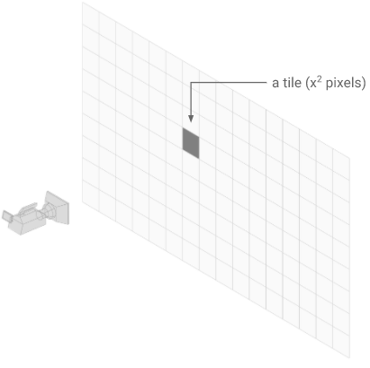

Figure . Example of render target tiles (Unity Technologies, 2019)

To create this list of lights for a tile, we cull the light volumes against the view frustum that is created by the tile from the camera (Figure 6.6). This tile frustum can be further optimised by sampling the minimum and maximum depth value of that from the depth buffer and using these values to calculate the frustum's near and far plane. We utilise compute shaders on the GPU to perform the culling as this task can be easily parallelised. Once these lists of lights have been created, we then pass them onto the fragment shader which loops through the lists for each tile and calculates its final colour.

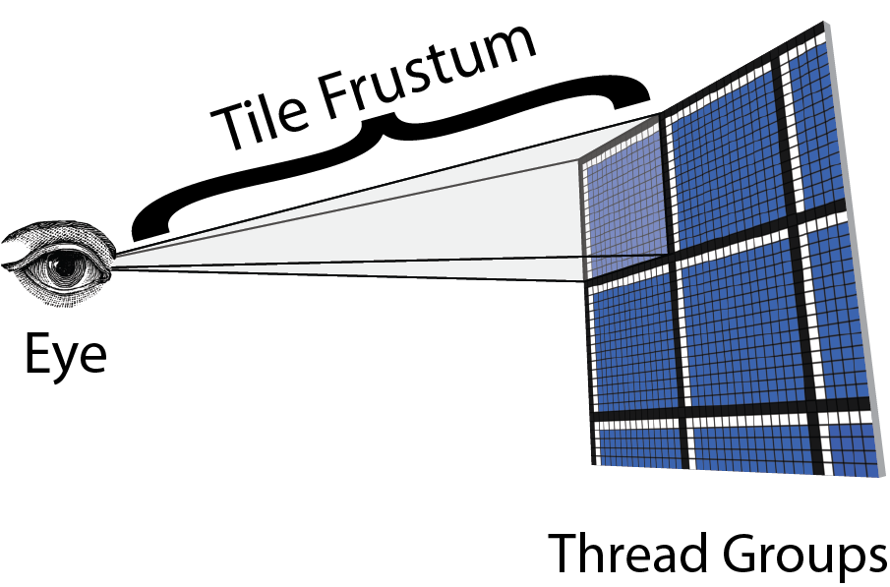

Figure . Example of tile frustums in tiled shading (Jeremiah, 2015)

## Clustered Shading

Clustered Shading is an advancement on tiled shading. Tiled shading splits the render target into 2D tiled, while clustered shading splits the whole view frustum into 3D cells called clusters. Unlike tiled shading, where tile frustums were created according to the min and max depth recorded in a cell, clustered are independent of scene geometry and are instead dependent on the cameras view matrix (Akenine-Möller, et al., 2018).

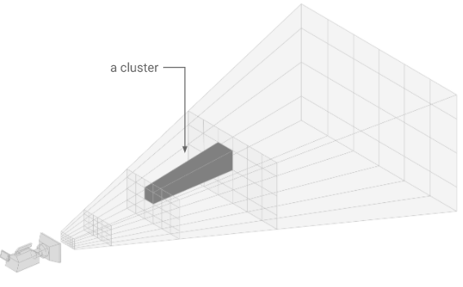

Figure . Clustered shading cluster example (Unity Technologies, 2019).

Similar to tiled shading, lists of lights are created by culling light volumes against these clusters. However, these lights are now in an array that will be queried according to an object's position to retrieve all lights that it will be affected by in the fragment shader. Clustered shading offers an improvement over tiled shading in that it has support for transparent objects, and the light lists generated are generally shorter than tiled shading as the light volume culling is more accurate (Akenine-Möller, et al., 2018). Like tiled shading, clustered shading can also be used in either forward rendering architectures or deferred shading architectures.

### Generating the Clusters

We begin by separating the view frustum into tiles like in tiled shading and then subdividing the frustum along the depth axis a set number of times. In the original paper, which presented clustered shading, Olsson et al. set out the following formula for calculating the depth slices :

$$k=\left\lfloor \frac{\log{(-Z_{vs}/near)}}{\log{(1+\frac{2\tan{θ}}{S_{y}})}}\right\rfloor$$

Equation . Original depth slice formula (Olsson, et al., 2012)

Where $k$ represents the depth slice, $Z_{vs}$ is the view space depth, $near$ is the near plane depth, $θ$ is half the field of view and $S_{y}$ is the number tiles on the y-axis.

The problem with this formula is that it is not very configurable and will create many clusters for a scene that may not necessarily need them. Instead, I utilised the technique used by the game "Doom 2016" which presents the following formula to create the depth slices:

$$Z={Near}_{z}{(\frac{{Far}_{z}}{{Near}_{z}})}^{slice / numSlices}$$

Equation . Configurable depth slice formula (Ortiz, 2018)

Where $Z$ represents depth, ${Near}_{z}$ and ${Far}_{z}$ represent the near and far plane respectively and slice and numSlices are the current subdivision corresponding to the depth value $Z$ and the total number of subdivisions.

Then to recover the slice index when performing the shading pass, we utilise Equation 6.3:

$$slice=\left\lfloor \log{(Z)}\frac{numSlices}{\log{( {Far}_{z}/ {Near}_{z})}}-\frac{numSlices*log⁡( {Near}_{z})}{\log{( {Far}_{z}/ {Near}_{z})}}\right\rfloor$$

Equation . Depth slice recovery formula

What is very useful about the above equation is that the only variable value is $Z$ so we can precompute both fractions ahead of time which allows us to avoid highly costly log table lookups on the GPU.

For my clustering system, I divide the view frustum into 32 * 32 tiles along the x and y-axis and perform 16 subdivision along the z-axis.

Strictly speaking, the clusters should be frustum shaped; however, to keep the lighting culling stage fast, we can represent the clusters as axis-aligned bounding boxes that enclose each cluster. AABBs also provide another benefit in that by being slightly larger than the original frustum, we ensure that no gaps between clusters occur because of floating-point inaccuracies (Ortiz, 2018).

Cluster generation only needs to take place when the view matrix of the camera changes. Otherwise, the clusters can be reused each frame.

### Determining Active Clusters

Typically, a naïve implementation of clusters shading involves culling lights against all the clusters in the view frustum. However, this is not optimal as some clusters will not contain any geometry to shade. Therefore, the lights in that cluster will not be used, and the time spent on the culling lights against this cluster will have been wasted. To avoid this, we can mark which clusters contain geometry and which clusters do not. This will allow us to only perform light culling against clusters that actually contain geometry.

One stated downside to this techniques is that it requires a Z pre-pass (Ortiz, 2018). However, as I utilise a deferred shading system, I already have this Z pre-pass contained in the G-buffer, so no extra cost is incurred. Also, as my transparency algorithm requires two passes, I can utilise the first pass to mark active clusters for transparent geometry at no extra cost.

Clusters are stored in memory as two 4 dimensional vectors representing the min and max vertex of the cluster AABB. We are required to use 4D vectors as GPU memory must be 16bit aligned. Therefore we can utilise the W component of the min vertex to store whether a given cluster contains any geometry or not. This process results in a significant speedup when performing the light culling step.

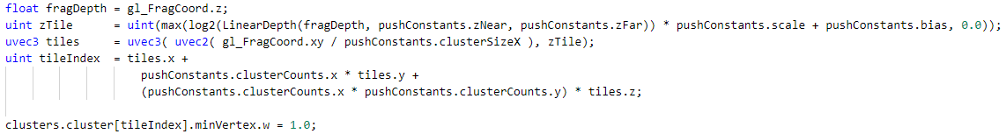

Code Sample . Example of code that marks active clusters. This is run in the fragment shader.

### Culling the Lights

For the next step, we must cull the lights against the clusters and assign relevant lights to those clusters. For this, we must define the light volume. A light volume represents the area around a light where its effect will be visible.

There are two methods for defining the light volume:

1. We can either create a threshold based on the light's falloff, which is proportional to the inverse square of the distance from the light source and after this threshold, the effect of the light no longer applies;
2. We can explicitly provide a cut off range for the light.

In my case, I use the range method as it gives us more control over specifying the area that a light affects.

For point lights, this effectively boils down to an AABB vs sphere collision test where the AABB is the cluster and sphere represents the light volume for the light where the sphere is centred on the point lights position.

The AABB Sphere collision test for point lights is performed by checking the distance between the point lights position and the cluster AABB. If the distance is less than the range of the point light, then light is intersecting with that cluster.

The light culling takes place in a compute shader which is dispatched with one working group per cluster. Each working group has 64 threads that concurrently loop through the list of points lights and perform the collision tests.

### Shading the Scene

After gathering the list of lights for each active cluster, shading then takes place in two separate stages—one for opaque geometry and a second for transparent geometry, both working in similar ways.

To begin, we must calculate which cluster the geometry at the current pixel is in. This can be done using Equation 6.3 to work out which Z slice the current pixel is in by using the current depth value and then using this depth value along with the x and y pixel coordinates to calculate the index of the relevant cluster.

Next, we loop over each light in the cluster and apply the standard PBR lighting calculations for each light.

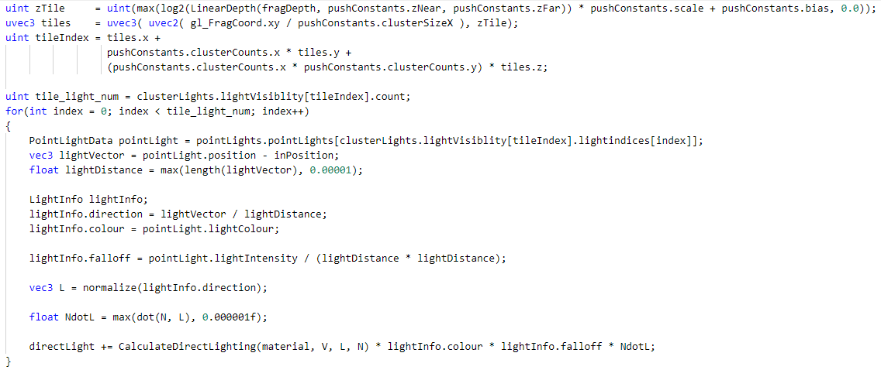

Code Sample . Example of shading code using clustered shading

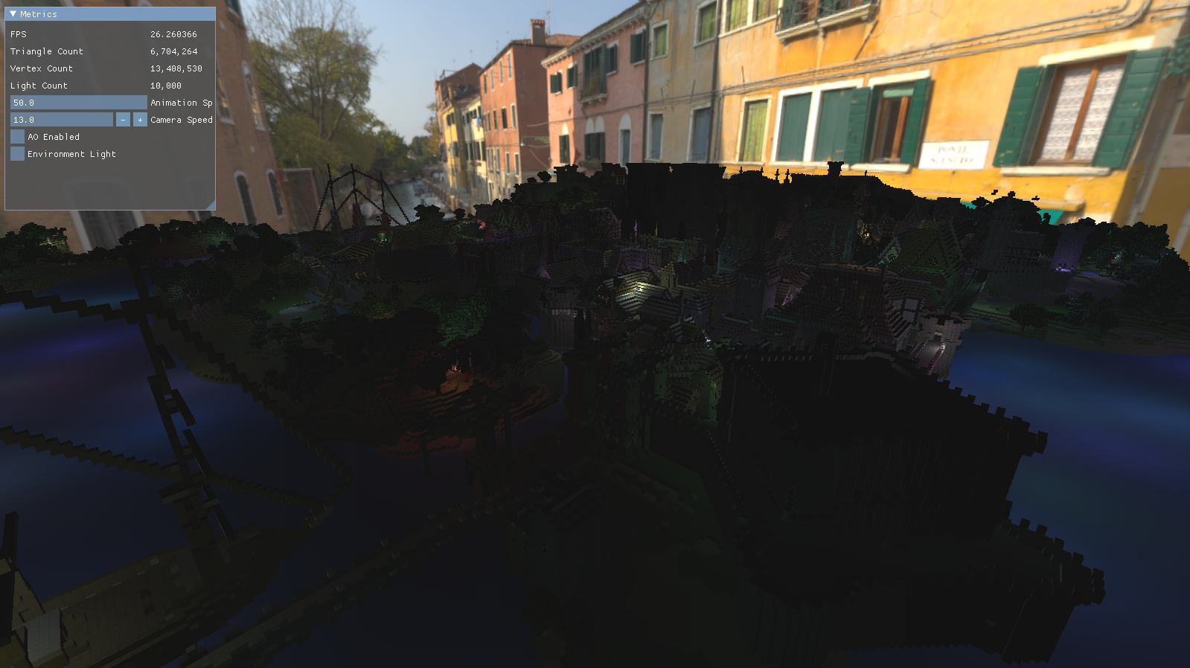

Figure . Scene rendered using clustered shading with 6.7 million triangles and 10,000 dynamically moving point lights (This scene is intentionally quite dark as the light sources are small and environment light has been disabled).

# Transparency

In 3D rendering, transparent materials require specialised techniques to model the effect on light as it passed through the material. These specialised techniques also need to correctly display any opaque materials that may be behind the transparent material. In this chapter, I will go over some of the techniques that exist to achieve this effect, along with the final technique that I chose for this project.

## Introduction

Transparency is the property of a material that allows light to pass through it without scattering the light. The light can be said to follow Snells Law. Snell's law states that the ratio of the sines of the angles of incidence and refraction is equivalent to the ratio of phase velocities in the two media, or equivalent to the reciprocal of the ratio of the indices of refraction (Wikipedia, n/a).

Materials can also be translucent, where light can pass through them, but this light undergoes scattering events. In a basic material model, the transparency of a material is defined by the value of the albedo textures alpha channel. This alpha value represents the opacity of an object for a given pixel. An alpha of 1.0 (or 255 when dealing with 8-bit textures) means the pixel is opaque; 0.0 means the pixel is fully transparent (Akenine-Möller, et al., 2018).

The amount of light transmitted through a translucent material can be computing using:

$$T_{r}=e^{-σ_{t}d}$$

Equation . Amount of light transmitted through a translucent material

Where $d$ is the distance travelled through the material and $σ_{t}$, the extinction parameter, represents the rate at which light drops off as it travels through the material (Akenine-Möller, et al., 2018).

## Sorted Transparency

Traditionally the most common method to render transparent materials was to sort your scene along the view space Z-axis and render the scene from back to front. The pixel colours are then composited using alpha blending using the over operator (Dunn & Bavoil, 2014)

$$C_{dst}=A_{src}C_{src}+\left(1- A_{src}\right)C_{dst}$$

Equation . Over blending operation, C = pixel colour, A = pixel alpha value.

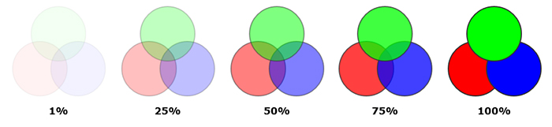

Figure . Example of alpha blending (Dunn & Bavoil, 2014)

However, this solution has fallen out of use in modern rendering engines as it has several problems. To get perfect results, sorting objects by their Z depth is not enough, there can be cases where the depth ranges of multiple objects intersect, and the objects will need to be dynamically split up to allow for pixel-perfect depth sorting. This introduces significant overhead, and it is also challenging to implement a good mesh dissection algorithm. The need to render objects sorted by their depth is also a significant disadvantage when using modern graphics APIs such as Vulkan. Vulkan allows you to record GPU commands from many threads at once. Rendering meshes one at a time back to front created a significant bottleneck in these APIs as this section of the rendering pipeline will be restricted to execute on a single thread to maintain the desired rendering order.

## Order-Independent Transparency

To overcome the drawbacks of sorted transparency, a new family of rendering algorithms were developed known as order-independent transparency. As the name suggests, no prior sorting is required to render transparent materials.

Many different types of order-independent transparency (OIT) algorithms have been developed. The most accurate of which is the depth peeling algorithm. Depth peeling involves rendering a scene multiple times and each time ‘peeling away’ layers of the image according to their depth and recording the colour of a pixel at each depth level. The major downside of depth peeling is that you need to render the scene as many times as the depth complexity of the scene. If the scene has many overlapping transparent objects, this algorithm can no longer operate in real-time (Kern, et al., 2020).

A more popular OIT algorithm that overcomes depths peelings issues with a complex scene is Weighted Blended OIT. Weighted Blended OIT (WBOIT) can render transparent objects in a single render pass without any depth sorting. Its core idea is to use an additive blending operation to compute a weighted average of the translucent colours with a weighting function that falls off as the linear depth increases (NVidia, n/a). WBOIT provides a real-time solution for transparency in a scene independent of the scenes depth complexity and has had more widespread adoption when compared to depth peeling.

However, WBOIT has quite a few drawbacks. The developers of the Total War franchise criticised WBOIT as it contains a lot of “magic numbers” / parameters in the algorithm, which leads to a lot of artefacts in the rendered image that are difficult to overcome without manual parameter tweaking. However, the main drawback of WBOIT that the Total War developers found with the algorithm is that it could not handle opaque object objects being rendered at the same time as transparent objects (Rabel, 2019). This situation can arise when a material has a configurable transparency value that can be changed at runtime, and if this value reaches 1.0 (i.e. fully opaque), the algorithm fails to render the material correctly. This poor handling of opaque and near opaque material can also create a cartoonish look to a scene when objects of varying opacity overlap, which will seriously detract from a scene's realism.

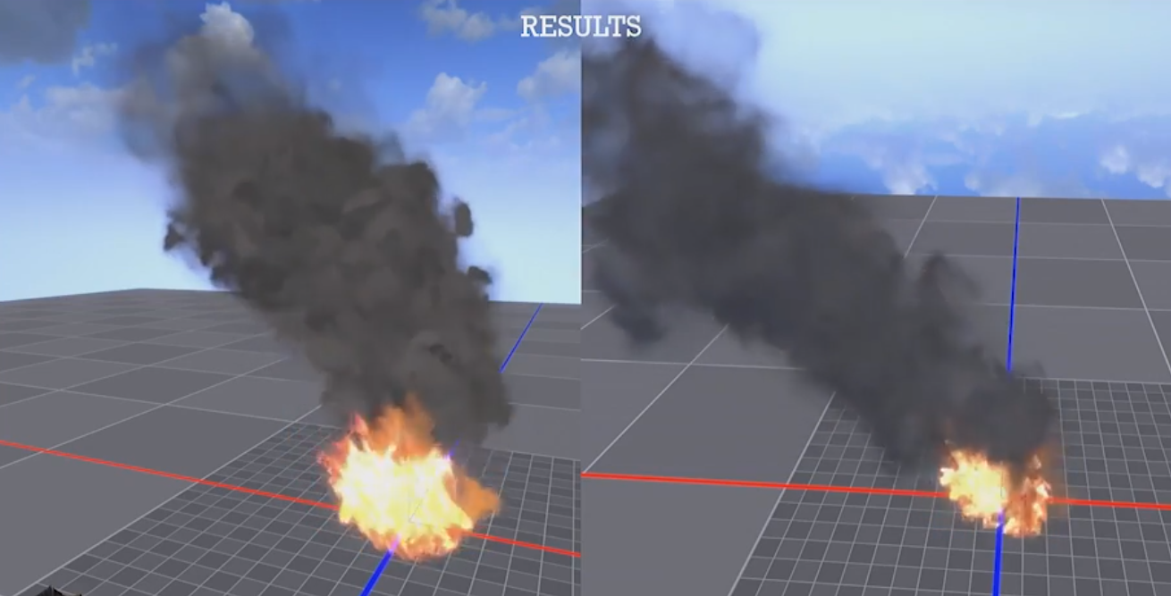

Figure . WBOIT (left) vs MBOIT (right). Note the strange darkening and depth discontinuities in the smoke on the left image caused by WBOITs inability to render near opaque materials.

The Total War developers suggested an alternative OIT algorithm known as Moment-Based Order-Independent Transparency (MBOIT) to overcome these issues.

## Moment-Based Order-Independent Transparency

MBOIT is an order-independent transparency technique that bases itself on the theory of moments. The moments of a mathematical function are quantitative measures related to the shape of the function's graph (Wikipedia, n/a). In the variation of MBOIT that I have implemented, the moments of the transparency functions are the view space depth values raised to various powers.

### Implementation

Like most transparency rendering techniques MBOIT renders transparent geometry separate from non-transparent geometry. Rendering transparent materials using MBOIT involves three steps:

1. Render the absorbance of each transparent material;
2. Render the transmittance of each transparent material;
3. Composite the results of the transmittance pass onto the results of the main opaque rendering pipeline.

**Absorbance Rendering**

Before rendering transparent geometry, we require a z-buffer depth pre-pass. However, as I use a deferred shading pipeline, this comes at no extra cost as we have this depth information in the G-Buffer. This depth buffer is used to only allow visible transparent geometry to be rendered, i.e. we will not attempt to render a transparency object that is fully occluded by an opaque object. Transparent geometry is rendered twice, once to determine the transmittance function per pixel and once to composite all the transparent surfaces together to get the final colour value. (Münstermann, et al., 2018)

The transmittance of a pixel at depth $z_{f}∈R$ is given by:

$$T\left(z_{f}\right)≔ \prod_{\begin{aligned}l=0 \\ z_{l}<z_{f}\end{aligned}}^{n-1}{(1-α_{l})}$$

Equation . Transmittance of pixel at depth $z_{f}$

Rather than implementing this multiplicative accumulation directly, Münstermann et al. choose to work in a logarithmic domain which leads them to define the absorbance at $z_{f}$ as:

$$A\left(z_{f}\right)≔-\ln\left(z_{f}\right)= \sum_{\begin{aligned}l=0 \\ z_{l}<z_{f}\end{aligned}}^{n-1}{(1-α_{l})}$$

Equation . Absorbance of pixel at depth $z_{f}$

Therefore transmittance, $b$, of a pixel at depth $z_{f}∈R$ is given by:

$$b≔ε_{z}\left(b\right)≔ \sum_{l=0}^{n-1}{-\ln\left(1-α_{l}\right)∙b(z_{l})}$$

Equation . Moment based transmittance of pixel at depth $z_{f}$

where $b(z)$ is the moment generating function. In my case, I use a 4 power moment so $b\left(z\right)={(z^{0}, z^{1}, z^{2}, z^{3}, z^{4})}^{T}$.

A simple render pass with additive blending allows us to write the vector into a render target with m+1 channels.

The zeroth moment stores the total absorbance by

$$b_{0}=\sum_{l=0}^{n-1}{-\ln\left(1-α_{l}\right)}$$

Equation . Total absorbance of pixel

Thus $exp⁡(-b_{0})$ is the total transmittance that has to be applied as the factor to the radiance of the opaque surfaces during the final compositing.

**Reconstruct the Transmittance**

We use the function $A(z_{f}, b, β)$ to approximate the absorbance at any depth $z_{f}∈[-1, 1]$, and from this, we can compute the transmittance using:

$$T(z_{f}, b, β)≔exp⁡(-A(z_{f}, b, β))$$

where $β$ is a bias value of 0.25. The bias value is used to correct for floating-point inaccuracies and rounding errors that occur during the calculations.

As mentioned earlier, I am utilising the algorithm using 4 power moments so the function $A(z_{f}, b, β)$ is defined by the algorithm:

|  |
| --- |
| **Algorithm:** Reconstruction of absorbance at any depth with 4 power moments  **Inputs: $b$** , the power moments. $z_{f}$ , the fragment depth. $β$ , the overestimation value.  **Output:** The approximation $A(z_{f}, b, β)$ |
| * Set $z_{0}≔z_{f}$ and $v_{0}= β$* Use a Cholesky decomposition (provided in Münstermann et. al.) to solve for $q∈R^{3}$. Where the first matrix is a Henkel matrix. $$\left(\begin{matrix}b_{0} & b_{1} & b_{2} \\ b_{1} & b_{2} & b_{3} \\ b_{2} & b_{3} & b_{4}\end{matrix}\right)⋅q=\left(\begin{matrix}z_{0}^{0} \\ z_{0}^{1} \\ z_{0}^{2}\end{matrix}\right)$$* Solve the following to obtain the roots $z_{1}$& $z_{2}∈R$: $$q_{2}⋅z^{2}+q_{0}⋅z^{1}+q_{0}⋅z^{0}=0$$* For $1≤l≤2$ set $v_{l}=1$ if $z_{l}<z_{0}$ else set $v_{l}=0$* Use divided different to solve a Vandermonde system for $u∈R^{3}$ $$\left(\begin{matrix}1 & z_{0}^{1} & z_{0}^{2} \\ 1 & z_{1}^{1} & z_{1}^{2} \\ 1 & z_{2}^{1} & z_{2}^{2}\end{matrix}\right)⋅u=\left(\begin{matrix}v_{0} \\ v_{1} \\ v_{2}\end{matrix}\right)$$* Return: $\sum_{j=0}^{2}{b_{j}⋅u_{j}}$ |

A generalisation of this algorithm exists within Münstermann et. al.

In the second additive rendering pass, we render and shade all the transparent surfaces, compute the absorbance and composite them into an off-screen render target in accordance with:

$$\sum_{l=0}^{n-1}{L_{l}∙α_{l}}∙T(z_{f}, b, β)$$

For pixels with $b_{0}=0$, the pixel has no opacity and the fragment shader can do an early return to avoid this costly calculation.

**Final Image Composition.**

After the opaque geometry render pass and the two additive passes for the transparent geometry, we will have 3 render targets showing opaque and transparent surfaces along with transparent surfaces absorbance values.

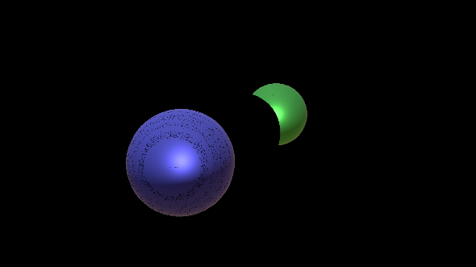 

Figure . Left: transparent material, Right: absorbance values for each pixel

To composite the opaque geometry with the transparent geometry, we multiply the opaque geometry by $e^{-b_{0}}$ and add the colour value of transparency render target at the corresponding pixel. If $L_{n}$ is the radiance of the opaque surface, the full equation for the image compositing is:

$$\exp\left(-b_{0}\right)∙L_{n}+\frac{1-exp⁡(-b_{0})}{\sum_{l=0}^{n-1}{α_{l}∙T(z_{f}, b, β)}}∙\sum_{l=0}^{n-1}{L_{l}∙α_{l}}∙T(z_{f}, b, β)$$

Equation . Image composition equation (Münstermann, et al., 2018)

where $\frac{1-exp⁡(-b_{0})}{\sum_{l=0}^{n-1}{α_{l}∙T(z_{f}, b, β)}}$ serves as a normalisation factor to image composition so that the equation is energy conserving. i.e. No extra energy is introduced into the scene, this can happen if the sum of all the radiances is not equal to 1.

This normalisation factor is written to the alpha channel of the render target of the transparent geometry during transmittances reconstruction to improve efficiency. In some cases this normalisation factor reduces the accuracy, but it also reduces the chance of artefacts in the final images, which would be far more noticeable.

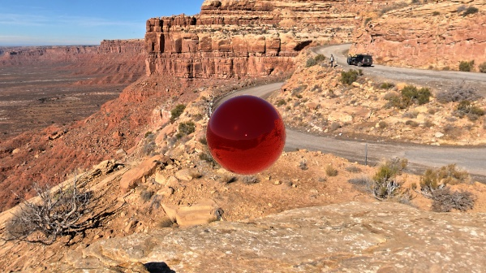 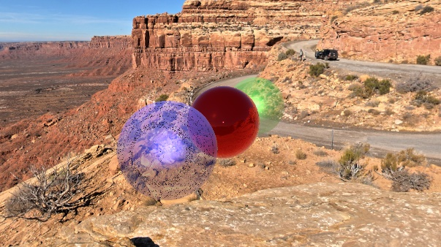

Figure . Left: Opaque material, Right: Final composited image

# Ambient Occlusion

Scenes rendered only by direct light appear very “flat” and do not provide a convincing realistic rendering of the scene. To achieve this realism, we needed a global illumination system. As a full global illumination system was out of scope for this project, I instead implemented techniques to model the occlusion of ambient light. This provides a small stepping stone towards full global illumination and an extra appearance of realism to a scene.

## Introduction

Ambient occlusion is a technique used in global illumination to simulate the shadows cast by objects blocking ambient light (Waage, 2010). Ambient occlusion is not an entirely physically-based effect and applies many simplifications to generate its results. However, the results it produces are plausible and vastly improve the realistic appearance of a scene (Akenine-Möller, et al., 2018).

Ambient occlusion tries to approximate indirect lighting being occluded by darkening creases, holes and surfaces that are close to each other. These areas are largely occluded by surrounding geometry, and thus lights rays have fewer places to escape to, causing them to appear darker (Learn OpenGL, 2014).

## SSAO

Ambient occlusion techniques can be quite expensive to compute as they need to take the surrounding geometry into account. One brute force method is to shoot a large number of rays in many directions for each point to determine its occlusion factor. To overcome this, Cryktek pioneered a technique known as Screen Space Ambient Occlusion (SSAO). SSAO utilises the scene's depth buffer to determine the amount of ambient occlusion instead of the scene's actual geometry data. The depth buffer can be thought of as a heightmap in the Z direction for all visible geometry (Learn OpenGL, 2014).

To perform SSAO, we perform the following procedures. For each pixel on the screen, we calculate an occlusion factor based on the pixels surrounding depth values. The occlusion factor is then used to reduce the indirect lighting component for that pixels lighting calculations. The occlusion factor is obtained by taking multiple depth samples in a sphere sample kernel surrounding the pixel position and comparing each of these samples with the current pixels depth values. The number of samples that have a higher depth value than the pixel’s depth represents the occlusion factor.

As this technique involves sampling, the quality of the results is directly related to the sample count. If the sample count is too low, then there will be artefacts showing in the final image known as banding. If the sample count is too high, then performance begins to suffer. By randomly rotating the sample kernel for each pixel, we can get much higher quality results with far fewer samples required. However, this randomness introduces its own form of noise in that there will be a noticeable noise pattern. To overcome this, we apply a blurring filter to the generated ambient occlusion map (Learn OpenGL, 2014).

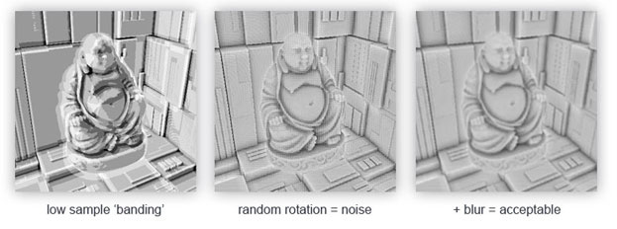

Figure . Examples of effects of low sample counts and random noise on SSAO quality

## HBAO

SSAO has some problems in that it can falsely darken areas of the scene, and it also can fail to detect certain features (k1DBLITZ, 2012). Researchers at NVIDIA invented a technique called Horizon Based Ambient Occlusion (HBAO) to attempt to overcome some of these issues. HBAO utilises a more physically based approach than SSAO to compute ambient occlusion (NVidia, n/a). Like SSAO, HBAO works by ray casting from a pixel using the depth buffer as a heightfield of the scene. It fires rays in a number of equiangular directions in a radius around the pixel. Bavoil et al. describe a spherical coordinate system with the zenith axis aligned with the view direction $\vec{V}$, azimuth angle $θ$ and elevation and elevation angle $α$ (Bavoil, et al., 2008). The azimuth angle rotates about the negated view space Z-axis and the elevation angle is relative to the XY plane. We then define a horizon line defined by $h(θ)$ and all rays that are cast below this line are known to intersect with an occluder.

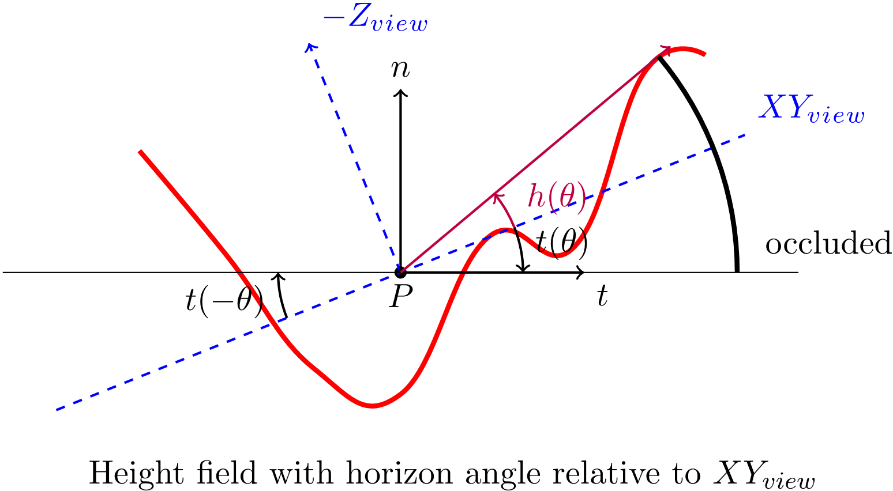

Figure . HBAO The red line represents an occlude. (Lenaerts, 2013)

A comparison of a scene using HBAO and a scene without ambient occlusion can be seen in Figure 8.3 & Figure 8.4. The effect has been exaggerated 2x as it was otherwise difficult to see the difference due to loss of colour precision when importing the images into this word document. The effect is particularly visible in the creases of the green curtain and the base of the pillar.

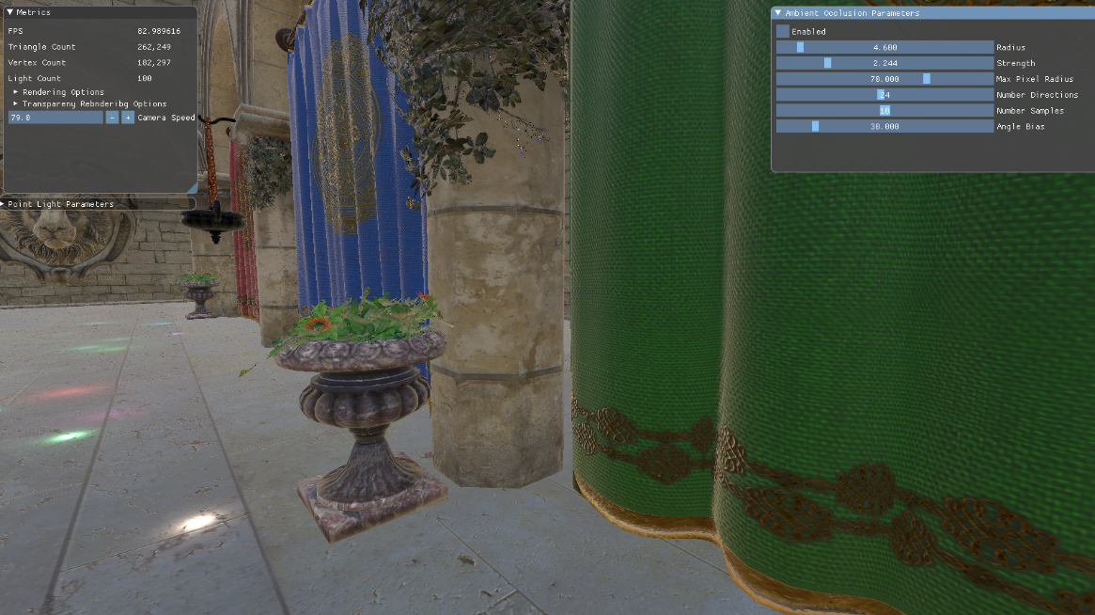

Figure . HBAO off

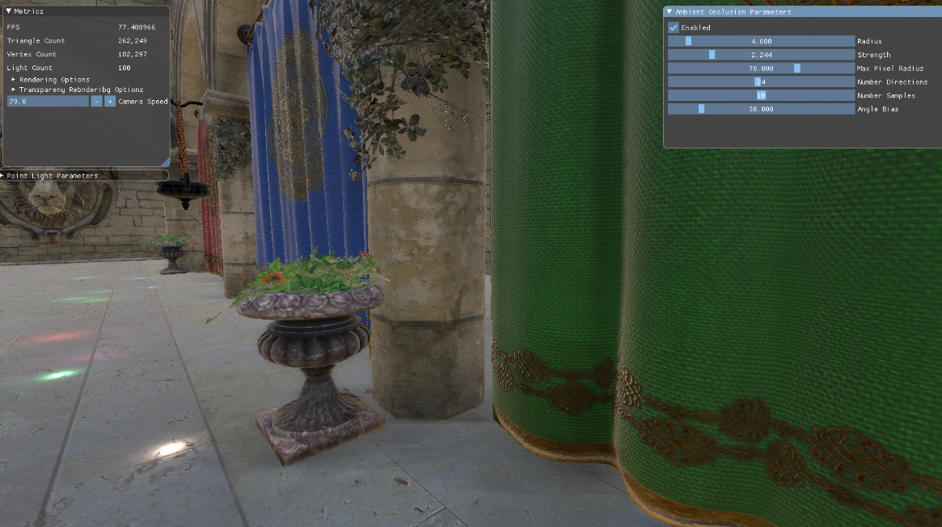

Figure . HBAO on

# Acceleration Structures / Culling

To develop an efficient rendering engine, we must ensure that the GPU does not undertake any unnecessary work. An example of unnecessary work is attempting to render objects that are not in the camera's view. To detect these object, we utilise acceleration structure and view frustum culling to prevent them from being sent to the GPU.

## Introduction

As graphics hardware has progressed, we have gained the ability to render at much higher resolutions than what used to be the case. Today 4K displays are beginning to become more commonplace in consumer setups. Moreover, consumers expect a minimum of 60FPS and even 120FPS in certain situations. However, with both display and refresh rate, there is diminishing returns as they increase. What is not capped at a limit is scene complexity. Scenes can always become more complex as graphics artists model more complex environments and represent a finer detail range. To allow scenes to expand their complexity, we must only submit relevant information to the GPU. Modern scenes have 100s of millions of vertices, and Z-buffering alone is not enough to cull this. For this, we must introduce acceleration algorithms and culling techniques to reduce the workload for the GPU (Akenine-Möller, et al., 2018).

## AABB

An axis-aligned bounding box (AABB) is one of the most common bounding volumes to use for culling or collision detection. An AABB is a cuboid where its face normal are at all times parallel with the axis of the coordinate system. AABBs benefit from fast overlap calculations when compared to other bounding volumes methods.

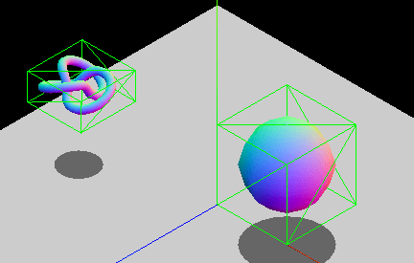

Figure . AABB (MDN contributors, 2021)

One method of representing AABBs is by defining their mix and max vertex

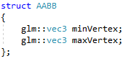

Code Sample . AABB struct definition

To calculate the AABB for a given mesh, we loop over all the vertices in the mesh when it is loaded in and work out its min and max value on each coordinate axis.

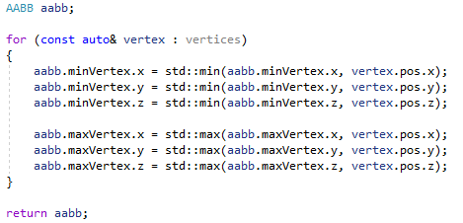

Code Sample . Calculating an AABB from a list of vertices

When the mesh is transformed, we must update its bounding box to reflect this. To do this, we apply the transformation to the original bounding box and work out the new min and max vertices from this transformed bounding box. While this method results in a larger than necessary bounding box, it is still favoured as it is very fast to compute (Ericson, 2004).

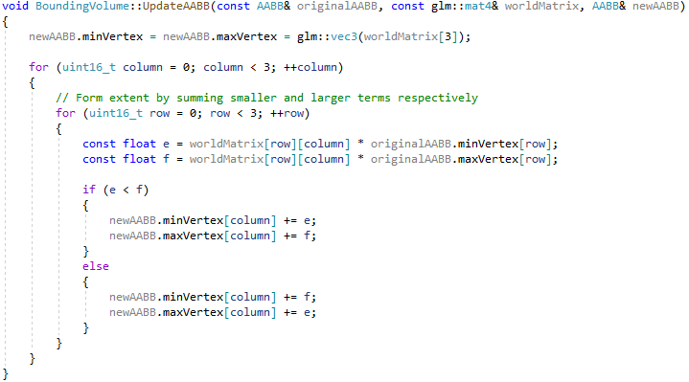

Code Sample . Transforming AABB to world space

Many alternatives other than AABBs exist for defining an object's course scale bounding volume. Two popular methods are bounding spheres and object-orientated bounding boxes (OBB). Bounding spheres offer a looser bounding volume for an object but a very fast collision detection calculation (If the distance between the centre of 2 bounding spheres is less than the sum of their radii, then the two bounding sphere overlap). While OBBs offer a tighter bounding volume but require much more complicated collision detection calculations. I found AABBs to be a good middle ground between bounding volume tightness and the efficiency of the collision detection calculations.

## View Frustum

The view frustum defines the boundary of the area of the scene that is visible to the camera. It can be represented by six planes, with each plane representing a side of the frustum.

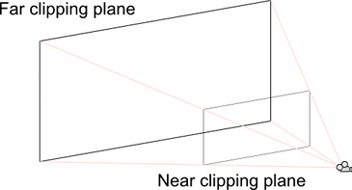

Figure . View Frustum (Unity Technologies, n/a)

The view frustum planes can be extracted from the view and projections matrices as described in (Gribb & Hartmann, 2001). The planes can be extracted according to the following table when using Vulkan and the GLM math library:

|  |  |
| --- | --- |
| **Clipping Plane** | **Coefficients for the plane equation** |
| Left | $$a= m_{41}+m_{11}$$ $$b= m_{42}+m_{12}$$ $$c= m_{43}+m_{13}$$ $$d= m_{44}+m_{14}$$ |
| Right | $$a= m_{41}-m_{11}$$ $$b= m_{42}-m_{12}$$ $$c= m_{43}-m_{13}$$ $$d= m_{44}-m_{14}$$ |
| Bottom | $$a= m_{41}+m_{21}$$ $$b= m_{42}+m_{22}$$ $$c= m_{43}+m_{23}$$ $$d= m_{44}+m_{24}$$ |
| Top | $$a= m_{41}-m_{21}$$ $$b= m_{42}-m_{22}$$ $$c= m_{43}-m_{23}$$ $$d= m_{44}-m_{24}$$ |
| Near | $$a= m_{31}$$ $$b= m_{32}$$ $$c= m_{33}$$ $$d= m_{34}$$ |
| Far | $$a= m_{41}-m_{31}$$ $$b= m_{42}-m_{32}$$ $$c= m_{43}-m_{33}$$ $$d= m_{44}-m_{34}$$ |

Where $m=transpose(projection⋅view)$

Following the plane extractions, we need to normalize the planes so that the normal vector of the plane is of unit length.

## Collision Detection

For a comprehensive culling system, we need to have the facilities for the following collision

1. AABB vs AABB Contains

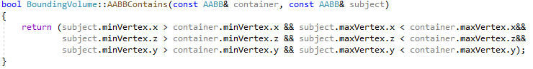

Code Sample . Code to check if one AABB is entirely enclosed by another AABB

1. AABB vs AABB Overlap

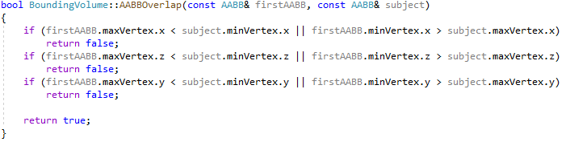

Code Sample . Code to check if two AABBs overlap

1. AABB vs Frustum

AABB vs Frustum is a slightly more complex process than the previous two methods. To check this, we must loop over each plane in the view frustum then we must get the point on the AABB that is furthest in the direction of the plane normal. We then project this point onto the plane and check whether it is in the plane’s halfspace or not. If the projected point is in the plane’s halfspace, we continue to test the other planes of the frustum. If the point is not in the plane’s halfspace, then the AABB is not colliding with the view frustum (iedoc, 2015).

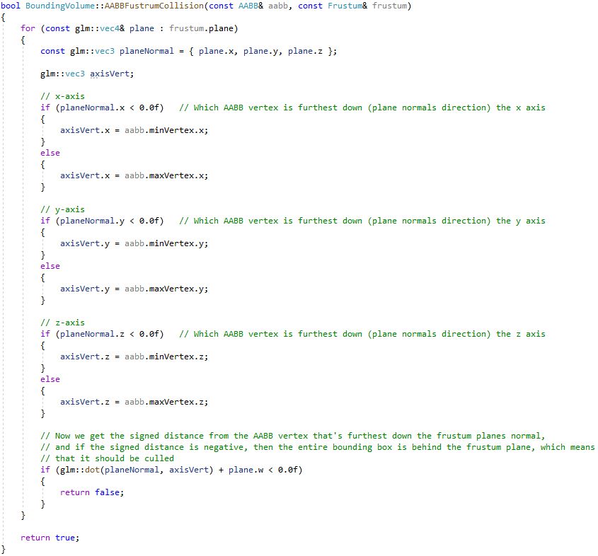

Code Sample . AABB - view frustum collision test

## Octrees

Brute force pairwise collision detection is far too slow ($O(n^{2})$). Instead, we must employ spatial partitioning techniques to provide broad phase collision detection by diving the scene into regions and then testing if the view frustum overlaps a region of the scene. As objects can only intersect if they overlap the same region, this drastically reduces the number of pairwise tests needed (Ericson, 2004).

Trees are a very useful data structure to use to represent spatial partitioning. Specifically, in my project, I chose to utilise *Octrees* to divide up my scene into regions. An octree is an axis-aligned hierarchical partitioning of a 3D space. It is modelled by a tree of nodes, and as the name suggests, each node has eight children. Additionally, each node has an AABB volume associated with it. The root node AABB generally encompasses the entire scene. This AABB is then subdivided into eight smaller equal-sized AABBs by simultaneously dividing the AABB in half along each axis (x, y, & z). This process is continued recursively down the tree until the stop condition is met. These stop conditions are typically a minimum count of objects contained within the region or else if the nodes AABB is smaller than a certain size.

A single octree for a scene is defined in world space coordinates, so it does do not need to be recalculated every frame or if the camera moves. Instead, an object is only required to recalculate its position in an octree if it has been transformed in some manner.



Figure . Example of an Octree (Truong, et al., 2019)

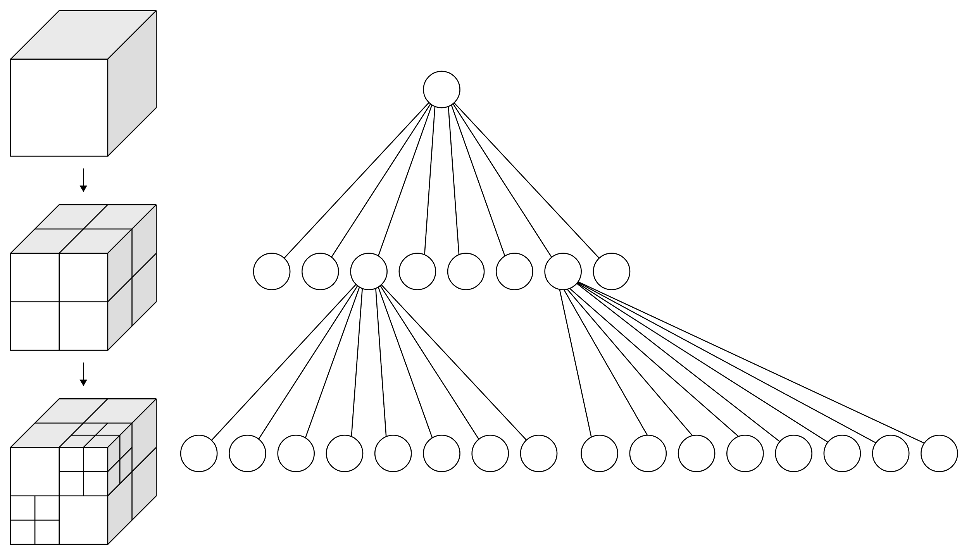

Figure . Spatial subdivision using an octree (Truong, et al., 2019)

To add an object to the octree, we first traverse down the tree, querying successive nodes until we find the node furthest down the tree, which entirely contains the object. We then add this object to a list of objects contained within that node.

To update objects in the octree that have been transformed during the previous frame, we remove these objects from the octree and reinsert them back into the octree to place them into their new correct node.

To utilise an octree for view frustum culling, we query the octree with our view frustum and traverse the tree. If the view frustum intersects with the AABB of a node of the octree, we then check the view frustum against the list of objects contained in that node along with its child nodes. If the view frustum does not interest with a nodes AABB, then that node and all its child nodes can be ignored. Throughout this traversal, we maintain a list of objects that have intersected with the view frustum. This resulting list of objects is all of the visible objects for that frame.

Below you can see the comparison between frame render times will culling enabled and culling disabled. The main section of the pipeline affected by culling is the G-Buffer generation. Here frustum culling resulted in a roughly 30% reduction in render time on the same scene.

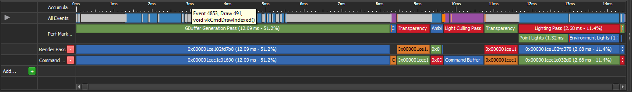

Figure . Culling Disabled. G-Buffer generation pass: 12.09ms

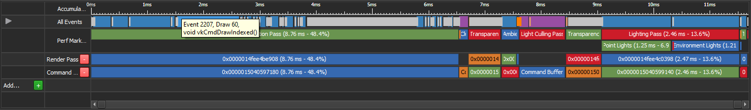

Figure . Culling Enabled. G-Buffer generation pass: 8.76ms

Octrees can be thought of as a specialisation of bounding volume hierarchies (BVH) that sacrifice bounding volume tightness for the speed at which the tree can be updated. This makes octrees very well suited to scenes with a lot of dynamically moving objects as the octree will not need to be completely recalculated every time an object is transformed. This speed also allows an octree to be also utilised for static geometry in a scene. Typically a separate spatial partitioning technique such as a BSP or even a BVH would be implemented for static geometry. However, for simplicity, I utilise octrees for all geometry types in my scenes as they offer a good compromise for both static and dynamic geometry.

# Conclusion

Overall I am very happy with how the project went. I feel I have been able to study and implement a large number of interesting rendering techniques, and I was able to render some quite complex scene at very high framerates. Below is a table containing some of the scenes I implemented and some information about those scenes.

These results were collected on a system with an Intel i5-6600k CPU @ 4.0GHz with 4 threads, 16GB of DDR4 RAM and an Nvidia GTX1060 3GB GPU.

|  |  |  |  |  |
| --- | --- | --- | --- | --- |
| **Scene Name** | **FPS** | **Triangles** | **Vertices** | **Dynamic Light Sources** |
| Sponza | ~65 | 262,249 | 182,297 | 100 |
| Amazon Bistro | ~120 | 1,043,077 | 815,288 | 3 |
| Rughold | ~23 | 6,704,264 | 13,408,530 | 10,000 |

As you can see, the framerate of a particular scene is more dependent on the number of lights in a scene more than the scene geometry. I would attribute this to the success of my rendering systems, my culling algorithms and acceleration structures.

From further testing on a more powerful system with a more modern CPU and GPU, it was possible to run the Rughold scene at ~80 FPS. From preliminary performance profiling of the application, the most significant performance bottleneck is transferring the data for the light sources to the GPU. This leads me to believe that with a more data orientated design, i.e. design my rendering engine with efficient data processing as a first-class priority, I could achieve better performance across all levels of hardware.

Throughout the project, several issues related to graphics programming kept reappearing that, with hindsight, could have been avoided. I faced many issues related to memory alignment and memory transfer from the CPU to the GPU. GPUs require memory to be aligned to 16-bit address values for certain buffer types. Many issues arose where the memory layout on the CPU would not match the expected memory layout on the GPU, causing GPU buffers to be filled with incorrect values. To overcome this, I would recommend incorporating some form of reflection system to automatically generate your C++ structs for describing Vulkan uniform buffer layouts. The Khronos group specifically develops a framework to help in this task, SPIRV-Reflect. Manually defining these structures by hand lead to many cases where the CPU and GPU struct definitions were not correctly in sync.

Another issue that I feel is very important from the beginning of any graphics project that I missed out on is defining your coordinate system in detail. i.e. define which direction each axis points in and which direction positive and negative values on each axis face. It is also very important to have some form of visual display on the screen of these axis’ as this will highlight issues of incorrect coordinate systems early on. Many frameworks and tools use different coordinate systems. It is not always obvious which coordinate system various research papers or graphics resources follow. By having this visual displayed in your program, you can quickly rectify any discrepancies.

A significant shortcoming of mine in this project was a severe underestimation of the effort involved in completing this project to its original targets. Initially, I had intended to implement a comprehensive global illumination system. However, this system turned out to be far too complex to be able to implement in the given timeframe. Global illumination systems still have many unanswered questions for real-time rendering. A follow-up project could be entirely devoted to global illumination and the various techniques that are being researched. Traditional methods of global illumination using screen spaced reflections combined with reflection probes have reached their current limits as they do have an elegant solution for handling dynamic objects in a scene.

A fascinating development that I came across during this project was a paper released in July 2020 from computer graphics researchers at Zhejiang University in China (Hu, et al., 2020). This paper, “Signed Distance Fields Dynamic Diffuse Global Illumination”, presents a novel technique for computing global illumination for a scene by performing ray tracing against a signed distance field representation of a scene rather than the actual scene geometry. It offers comparable results to RTX ray-tracing at a much lower cost. If I were to continue this project, I would focus on this technique as it appears to me to offer the best solution to some of the problems currently faced in global illumination systems.

Another area I would focus on if I were to continue this project would be to explore my original stretch goal of creating a common wrapper framework for Vulkan and DirectX12. These two graphics APIs are conceptually quite similar, so they would lend themselves nicely to having a common interface. This would provide the added benefit of allowing my rendering engine to run on the Xbox Series X console and would potentially offer stronger performance on Windows machines. This common interface could also, in theory, be extended to provide specialised rendering API support for specific platforms such as the Metal graphics API for Apple devices or Sonys’ proprietary graphics API for its PlayStation consoles.

# References

Akenine-Möller, T. et al., 2018. Accelaration Techniques. In: *Real-Time Rendering 4th Edition.* s.l.:A K Peters/CRC Press, p. 818.

Akenine-Möller, T. et al., 2018. Ambient Occlusion. In: *Real-Time Rendering 4th Edition.* s.l.:A K Peters/CRC Press, p. 446.

Akenine-Möller, T. et al., 2018. Clustered Shading. In: *Real-Time Rendering 4th Edition.* s.l.:A K Peters/CRC Press, pp. 899 - 900.

Akenine-Möller, T. et al., 2018. Deferred Shading. In: *Real-Time Rendering 4th Edition.* s.l.:A K Peters/CRC Press, pp. 883 - 887.

Akenine-Möller, T. et al., 2018. Environment Lighting. In: *Real-Time Rendering 4th Edition.* s.l.:A K Peters/CRC Press, p. 391.

Akenine-Möller, T. et al., 2018. Microfacet Theory. In: *Real-Time Rendering 4th Edition.* s.l.:A K Peters/CRC Press, p. 331.

Akenine-Möller, T. et al., 2018. Physics of Light. In: *Real-Time Rendering 4th Edition.* s.l.:A K Peters/CRC Press, pp. 293 - 306.

Akenine-Möller, T. et al., 2018. Tiled Shading. In: *Real-Time Rendering 4th Edition.* s.l.:A K Peters/CRC Press, p. 892.

Akenine-Möller, T. et al., 2018. Translucent Surfaces. In: *Real-Time Rendering 4th Edition.* s.l.:A K Peters/CRC Press, p. 624.

Akenine-Möller, T. et al., 2018. Transparency, Alpha, and Compositing. In: *Real-Time Rendering 4th Edition.* s.l.:A K Peters/CRC Press, p. 149.

Bavoil, L., Sainz, M. & Dimitrov, R., 2008. *Image-Space Horizon-Based Ambient Occlusion,* s.l.: ACM SIGGRAPH.

Burley, B., 2012. *Physically-Based Shading at Disney,* s.l.: Walt Disney Animation Studios.

CodingLabs.net, n.d. *Physically Based Rendering - Cook–Torrance.* [Online]   
Available at: http://www.codinglabs.net/article_physically_based_rendering_cook_torrance.aspx  
[Accessed 12 January 2021].

Dunn, A. & Bavoil, L., 2014. *Transparency (or Translucency) Rendering.* [Online]   
Available at: https://developer.nvidia.com/content/transparency-or-translucency-rendering  
[Accessed 11 April 2021].

Ericson, C., 2004. *Real-Time Collision Detection.* s.l.:Taylor & Francis Group.

Foley, T., 2015. *Next-Generation Graphics APIs: Similarities and Differences.* s.l., NVIDIA Corporation.

Gribb, G. & Hartmann, K., 2001. *Fast Extraction of Viewing Frustum Planes from the WorldView-Projection Matrix,* s.l.: s.n.

Halladay, K., 2017. *A Simple Device Memory Allocator For Vulkan.* [Online]   
Available at: http://kylehalladay.com/blog/tutorial/2017/12/13/Custom-Allocators-Vulkan.html  
[Accessed 11 April 2021].

Hebert, C., 2016. *Vulkan Memory Management.* [Online]   
Available at: https://developer.nvidia.com/vulkan-memory-management  
[Accessed 21 April 2021].

Hu, J. et al., 2020. *Signed Distance Fields Dynamic Diffuse Global Illumination,* Zhejiang: s.n.

iedoc, 2015. *(AABB) CPU Side Frustum Culling.* [Online]   
Available at: https://www.braynzarsoft.net/viewtutorial/q16390-34-aabb-cpu-side-frustum-culling  
[Accessed 11 April 2021].

Jeremiah, 2015. *Forward vs Deferred vs Forward+ Rendering with DirectX 11.* [Online]   
Available at: https://www.3dgep.com/forward-plus/#Forward  
[Accessed 19 January 2021].

Jordan, J., 2021. *What is the first 3D video game in the world?.* [Online]   
Available at: https://narrasoft.com/what-is-the-first-3d-game-in-the-world  
[Accessed 22 April 2021].

k1DBLITZ, 2012. *SSAO vs. HBAO vs. HDAO - What's the real difference?.* [Online]   
Available at: https://gaming.stackexchange.com/questions/95161/ssao-vs-hbao-vs-hdao-whats-the-real-difference  
[Accessed 11 April 2021].

Karis, B., 2013. *Graphic Rants - Specular BRDF Reference.* [Online]   
Available at: http://graphicrants.blogspot.com/2013/08/specular-brdf-reference.html  
[Accessed 14 January 2021].

Karis, B., 2013. *Real Shading in Unreal Engine 4.* s.l., Epic Games.

Kern, M. et al., 2020. *A Comparison of Rendering Techniques for 3D Line Sets with Transparency,* s.l.: s.n.

Khronos Group, n/a. *Compute Shader.* [Online]   
Available at: https://www.khronos.org/opengl/wiki/Compute_Shader  
[Accessed 11 April 2021].

Lagarde, S. & Rousiers, C. d., 2014. *Moving Frostbite to Physically Based Rendering 3.0.* s.l., SIGGRAPH.

Learn OpenGL, 2014. *SSAO.* [Online]   
Available at: https://learnopengl.com/Advanced-Lighting/SSAO  
[Accessed 11 April 2021].

Learn OpenGL, 2016. *Learn OpenGL - Deferred Shading.* [Online]   
Available at: https://learnopengl.com/Advanced-Lighting/Deferred-Shading  
[Accessed 15 January 2021].

Learn OpenGL, 2016. *Learn OpenGL - Diffuse irradiance.* [Online]   
Available at: https://learnopengl.com/PBR/IBL/Diffuse-irradiance  
[Accessed 14 January 2021].

Learn OpenGL, 2016. *Learn OpenGL - Specular IBL.* [Online]   
Available at: https://learnopengl.com/PBR/IBL/Specular-IBL  
[Accessed 14 January 2021].

Learn OpenGL, 2016. *LearnOpenGL - Theory.* [Online]   
Available at: https://learnopengl.com/PBR/Theory  
[Accessed 5 January 2021].

Learn OpenGL, 2016. *Lighting.* [Online]   
Available at: https://learnopengl.com/PBR/Lighting  
[Accessed 14 January 2021].

Lenaerts, D., 2013. *An alternative implementation for HBAO.* [Online]   
Available at: https://www.derschmale.com/2013/12/20/an-alternative-implementation-for-hbao-2/  
[Accessed 11 April 2021].

LunarG, Inc, 2016. *Descriptor Set Layouts and Pipeline Layouts.* [Online]   
Available at: https://vulkan.lunarg.com/doc/view/1.2.170.0/linux/tutorial/html/08-init_pipeline_layout.html  
[Accessed 11 April 2021].

McAuley, S., 2019. *Advances in Rendering, Graphics Research and Video Game Production.* s.l., Ubisoft.

MDN contributors, 2021. *3D collision detection.* [Online]   
Available at: https://developer.mozilla.org/en-US/docs/Games/Techniques/3D_collision_detection  
[Accessed 11 April 2021].

Münstermann, C., Krumpen, S., Klein, R. & Peters, C., 2018. *Moment-Based Order-Independent Transparency,* s.l.: s.n.

Neverender, 2010. *What is deferred rendering?.* [Online]   
Available at: https://gamedev.stackexchange.com/questions/74/what-is-deferred-rendering  
[Accessed 16 Janaury 2021].

Norman, J., n/a. *The First 3D Rendered Movie.* [Online]   
Available at: https://www.historyofinformation.com/detail.php?id=3560  
[Accessed 22 April 2021].

NVidia, n/a. *NVIDIA HBAO+ Technology | GeForce.* [Online]   
Available at: https://www.nvidia.com/en-gb/geforce/technologies/hbao-plus/technology/  
[Accessed 11 April 2021].

NVidia, n/a. *Weighted Blended OIT Sample.* [Online]   
Available at: https://docs.nvidia.com/gameworks/content/gameworkslibrary/graphicssamples/opengl_samples/weightedblendedoitsample.htm  
[Accessed 11 April 2021].

Olsson, O., Billeter, M. & Assarsson, U., 2012. *Clustered Deferred and Forward Shading,* s.l.: s.n.

Ortiz, Á., 2018. *A Primer On Efficient Rendering Algorithms & Clustered Shading.* [Online]   
Available at: http://www.aortiz.me/2018/12/21/CG.html  
[Accessed 11 April 2021].

Provenzano, A., 2019. *Vulkan Mobile Best Practices - Descriptor and Buffer Management.* [Online]   
Available at: https://community.arm.com/developer/tools-software/graphics/b/blog/posts/vulkan-descriptor-and-buffer-management  
[Accessed 11 April 2021].

Rabel, T., 2019. *Instancing and Order Independent Transparency in Total War: THREE KINGDOMS.* San Francisco, GDC.

Sawicki, A., 2018. *Memory Management in Vulkan™ and DX12.* San Francisco, Game Developer Conference.

The Khronos Group, 2021. *Vulkan Overiew.* [Online]   
Available at: https://www.khronos.org/vulkan/  
[Accessed 15 January 2021].

Truong, N., Arikatla, S. & Enquobahrie, A., 2019. *Octree-based Collision Detection in iMSTK.* [Online]   
Available at: https://blog.kitware.com/octree-collision-imstk/  
[Accessed 11 April 2021].

Unity Technologies, 2019. *Setting up the Rendering Pipeline and Lighting in Unity.* [Online]   
Available at: https://docs.unity3d.com/Manual/BestPracticeLightingPipelines.html  
[Accessed 19 January 2021].

Unity Technologies, 2020. *Unity - Manual: Types of light.* [Online]   
Available at: https://docs.unity3d.com/Manual/Lighting.html  
[Accessed 21 April 2021].

Unity Technologies, n.d. *Physically Based Sky.* [Online]   
Available at: https://docs.unity3d.com/Packages/com.unity.render-pipelines.high-definition@7.1/manual/Override-Physically-Based-Sky.html  
[Accessed 14 January 2021].

Unity Technologies, n/a. *Understanding the View Frustum.* [Online]   
Available at: https://docs.unity3d.com/Manual/UnderstandingFrustum.html  
[Accessed 11 April 2021].

Waage, Ó., 2010. *What is ambient occlusion?.* [Online]   
Available at: https://gamedev.stackexchange.com/questions/23/what-is-ambient-occlusion  
[Accessed 11 April 2021].

Wikipedia, n.d. *Light - Wikipedia.* [Online]   
Available at: https://en.wikipedia.org/wiki/Light  
[Accessed 5 January 2021].

Wikipedia, n/a. *Moment (mathematics).* [Online]   
Available at: https://en.wikipedia.org/wiki/Moment_(mathematics)  
[Accessed 25 April 2021].

Wikipedia, n/a. *Snell's law.* [Online]   
Available at: https://en.wikipedia.org/wiki/Snell%27s_law  
[Accessed 11 April 2021].